**7.VPC peering**

Create vpc networks asiasouth1 network id:-10.2.0.0/24 and us central1 network id:-10.3.0.0/24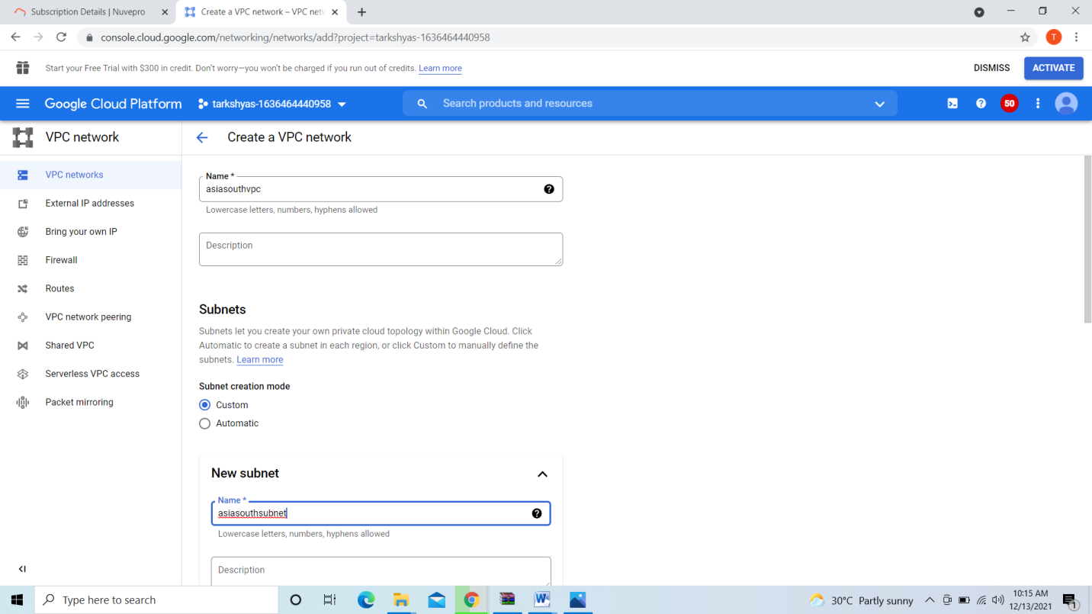

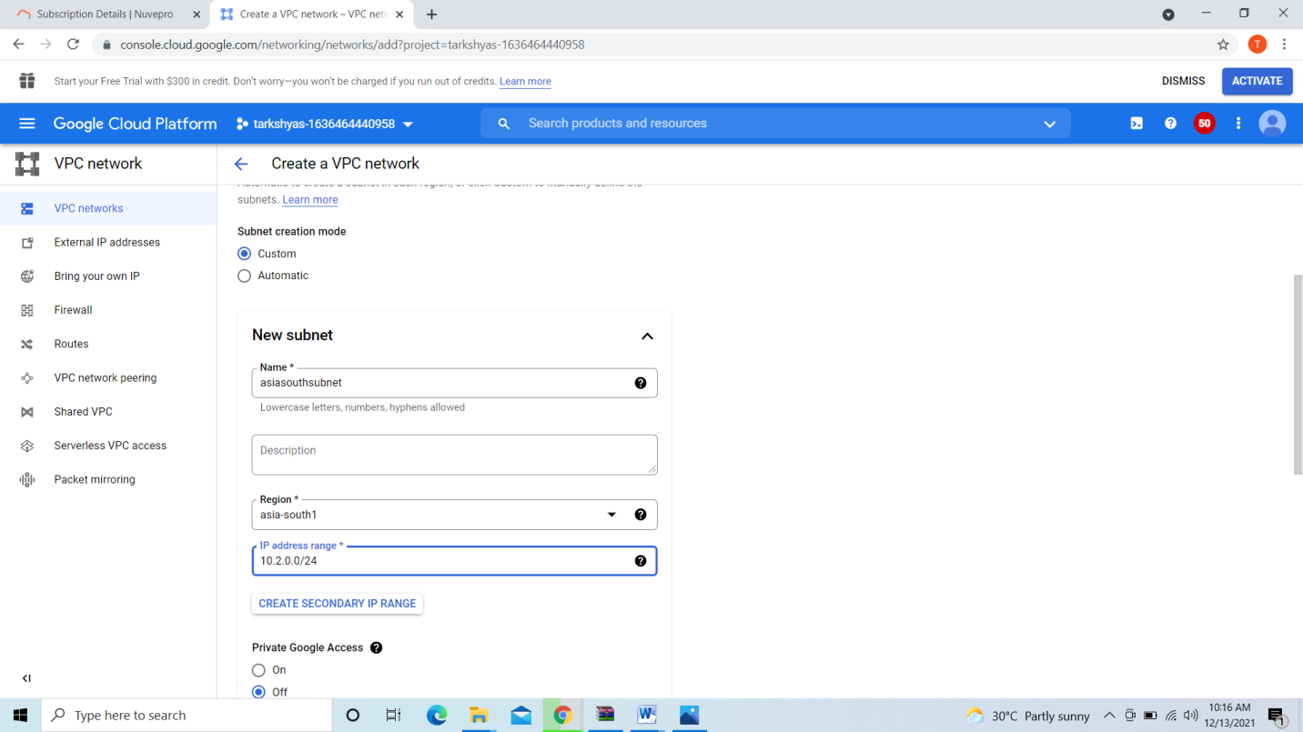

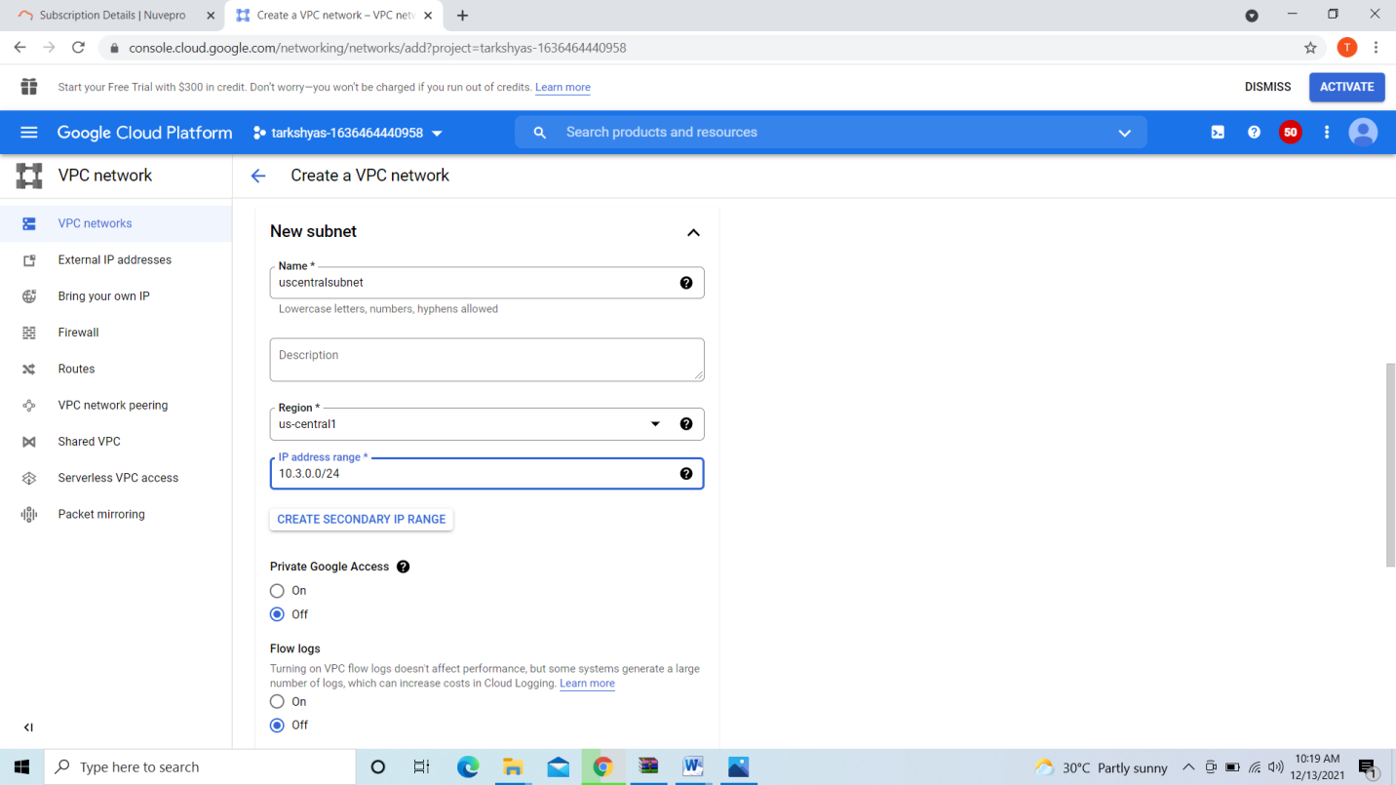

Create firewall rule for both networks

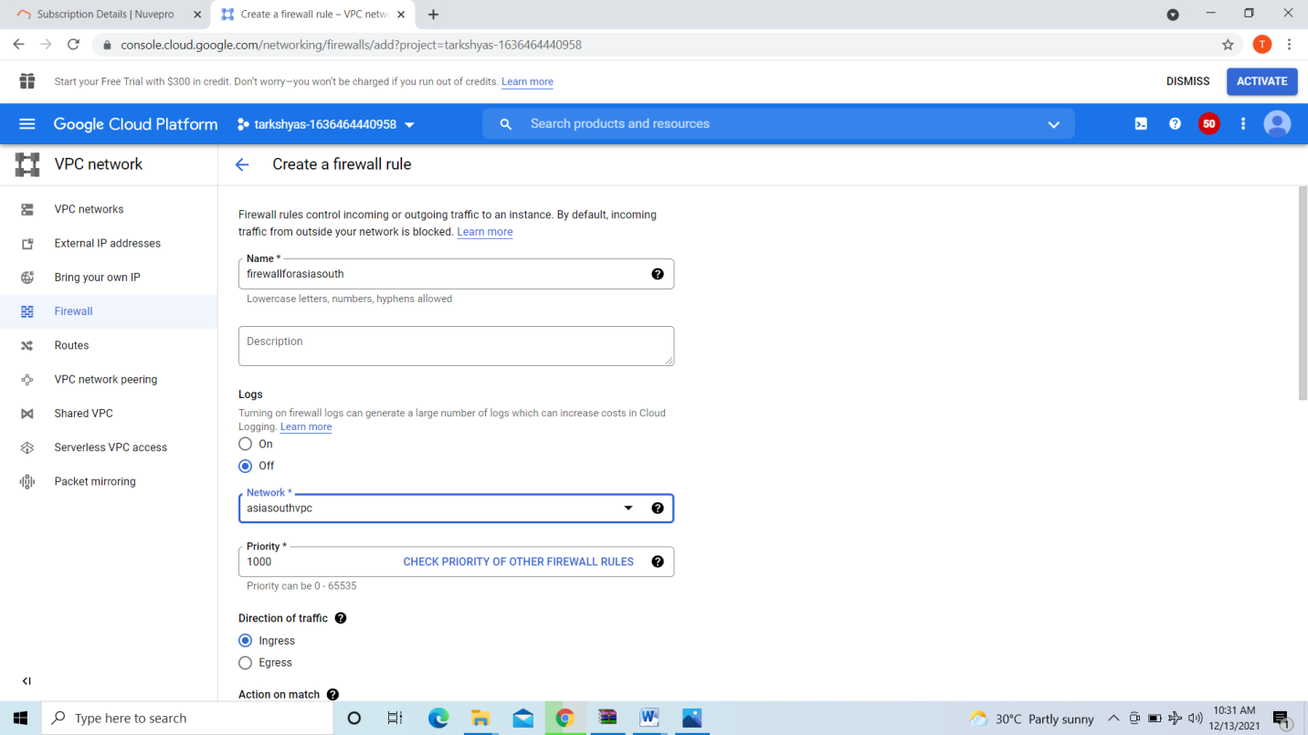

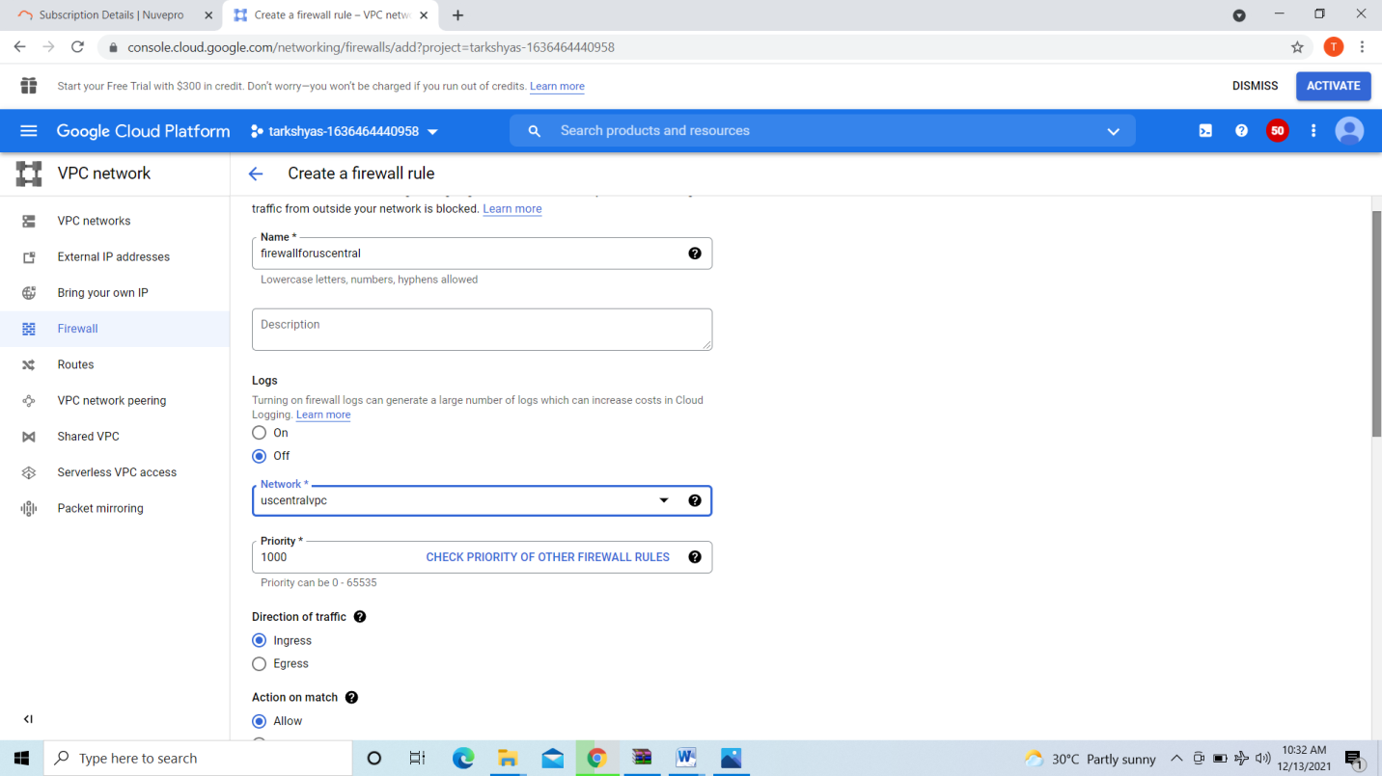

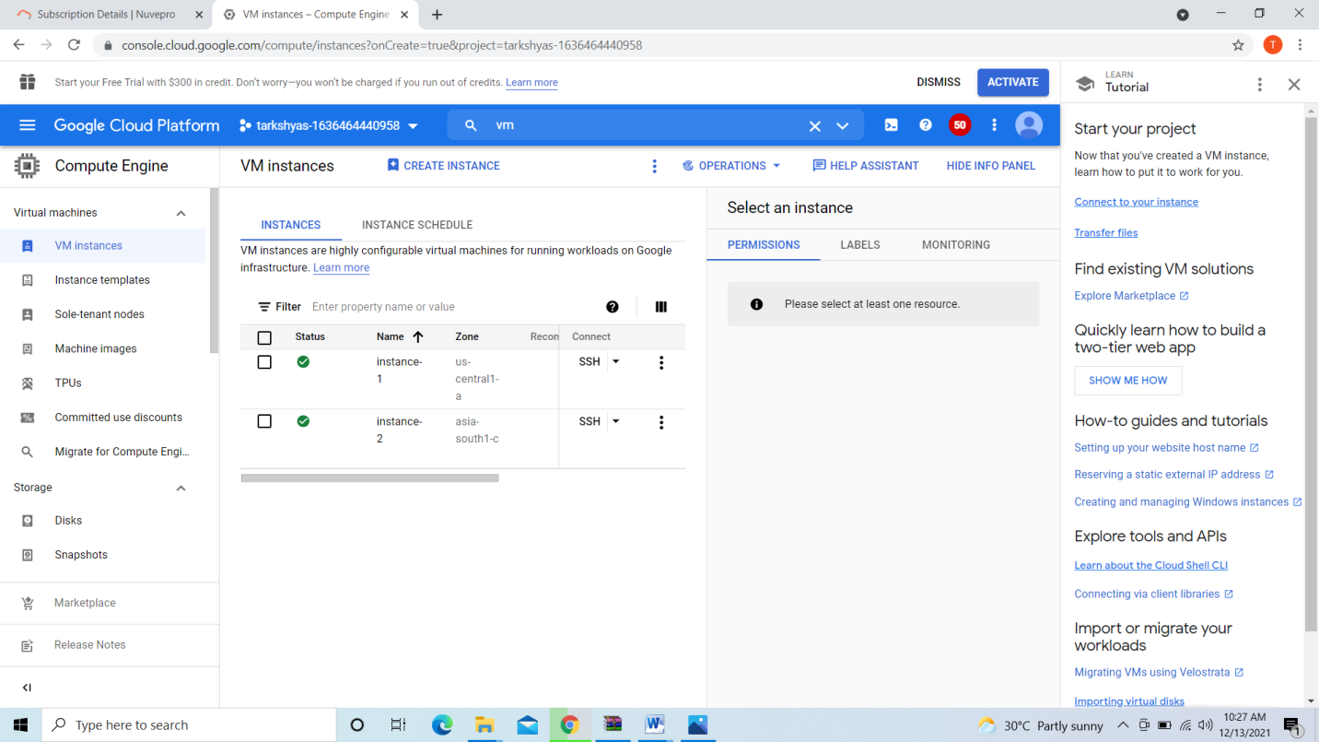

Created vm instance in both networks and create vpc network peering

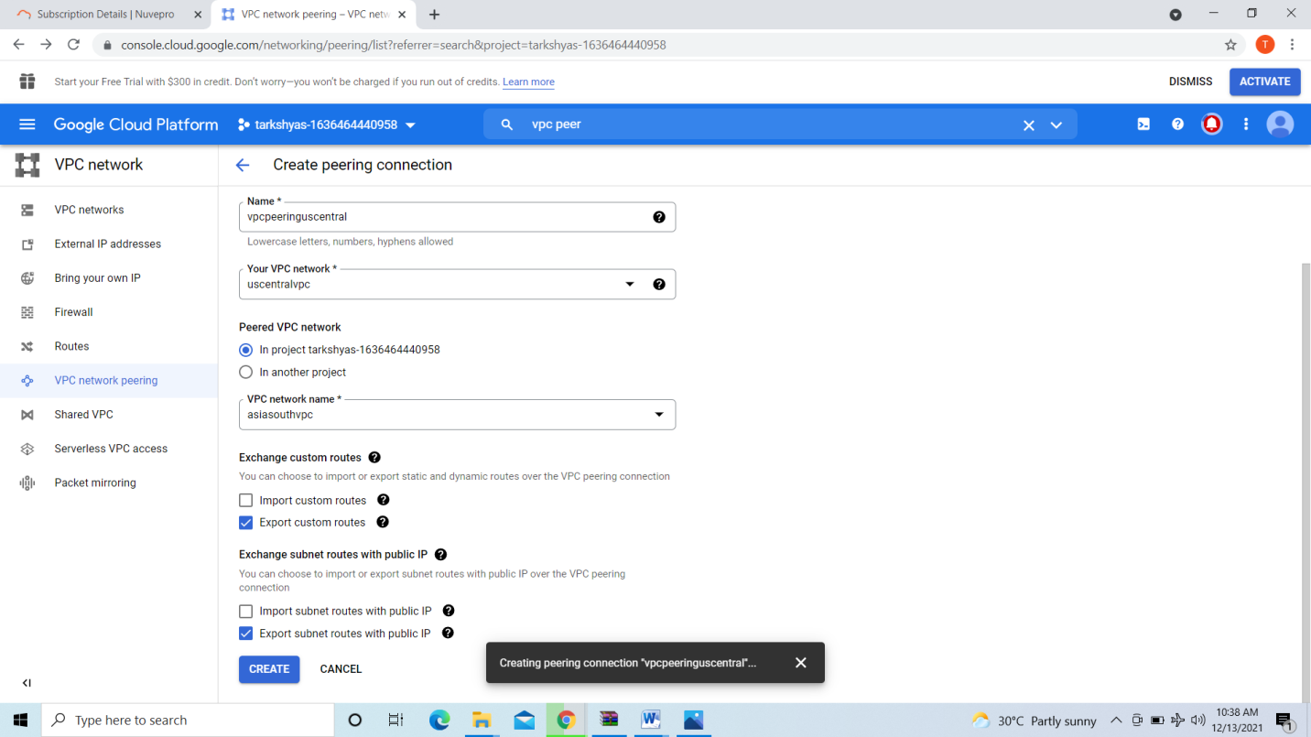

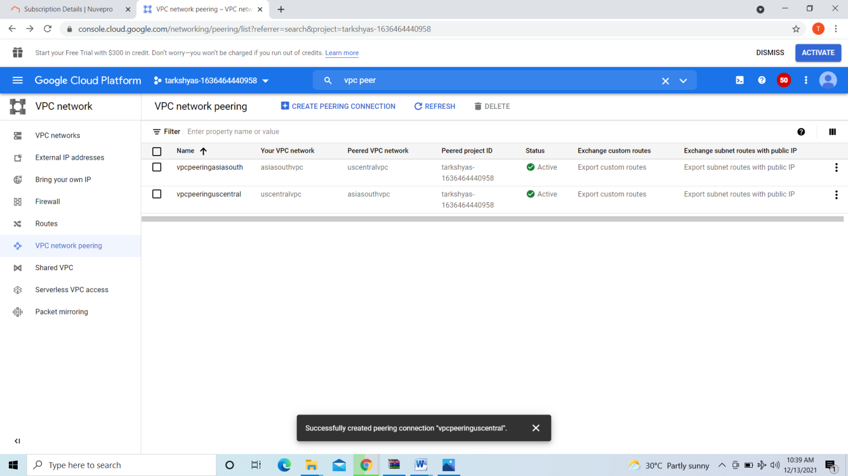

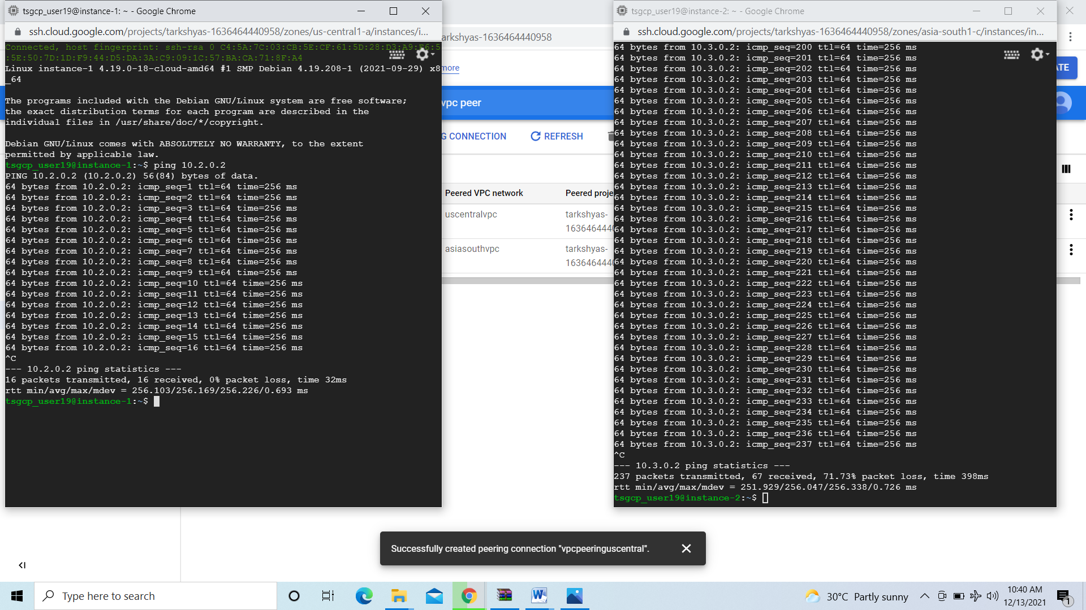

Now both networks vm is pingable.

**8.Terraform**

[**https://code.visualstudio.com/docs/?dv=win**](https://code.visualstudio.com/docs/?dv=win)

[**https://releases.hashicorp.com/terraform/**](https://releases.hashicorp.com/terraform/)

[**https://registry.terraform.io/providers/hashicorp/google/latest/docs/guides/getting_started**](https://registry.terraform.io/providers/hashicorp/google/latest/docs/guides/getting_started)

We can do terraform by installing terraform version and download the terraform.exe file and download the service account key that is json file open both files in visual studio and do the vm instance and cloudsql instance in the studio and deploy it with the help of command promt as shown below.

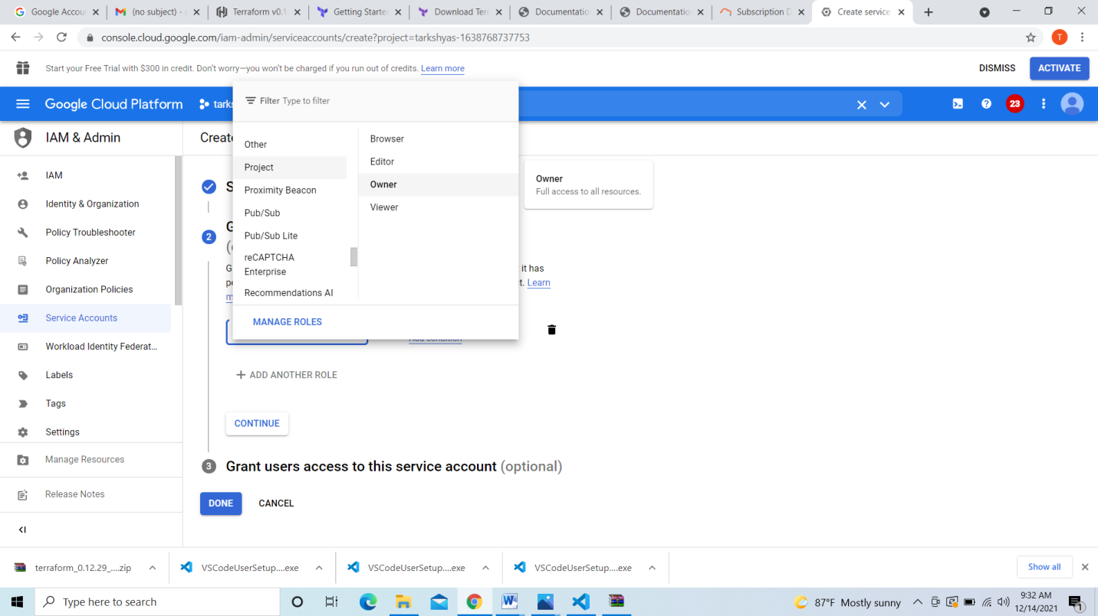

Create service account give permission project owner and download the key

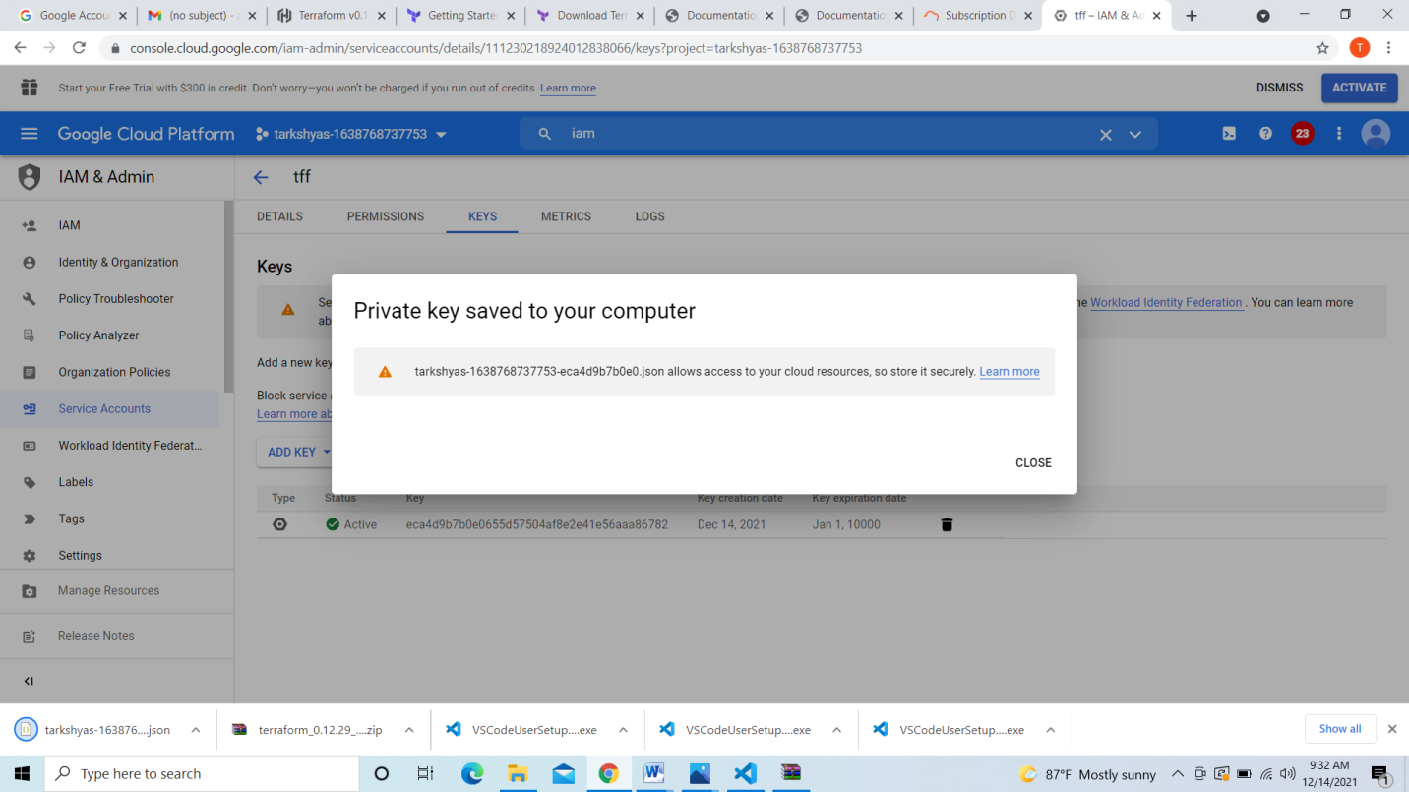

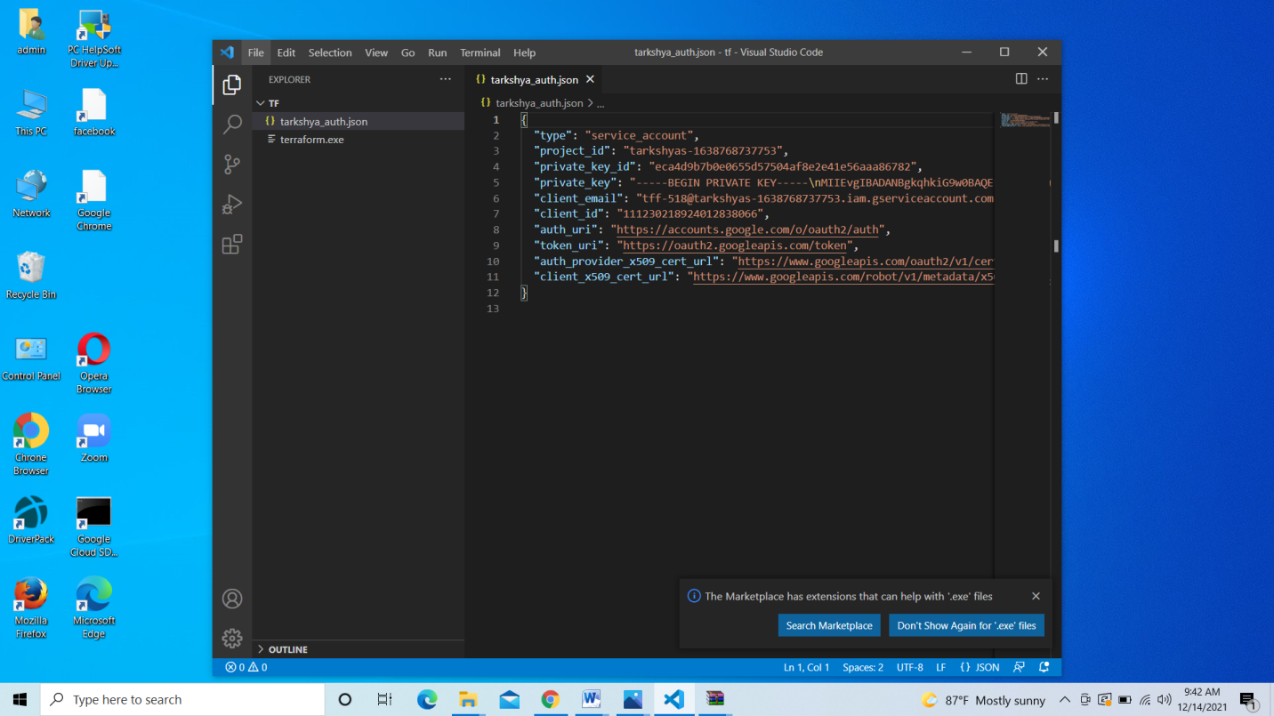

Here the tarkshya_auth.json file is the service account key and terraform.exe file is also there

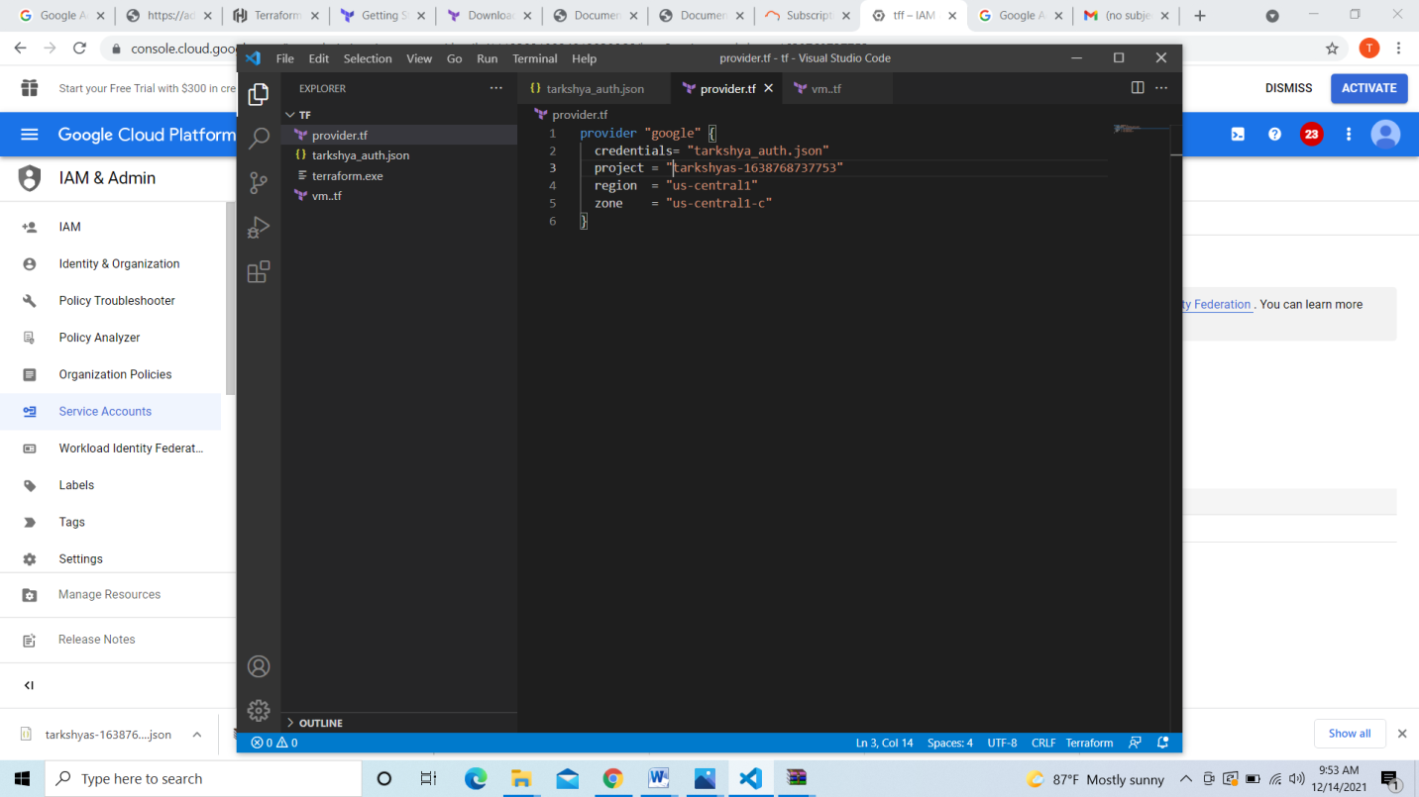

The provider.tf code is shown above credential file is service account key file & project is our current project and select region

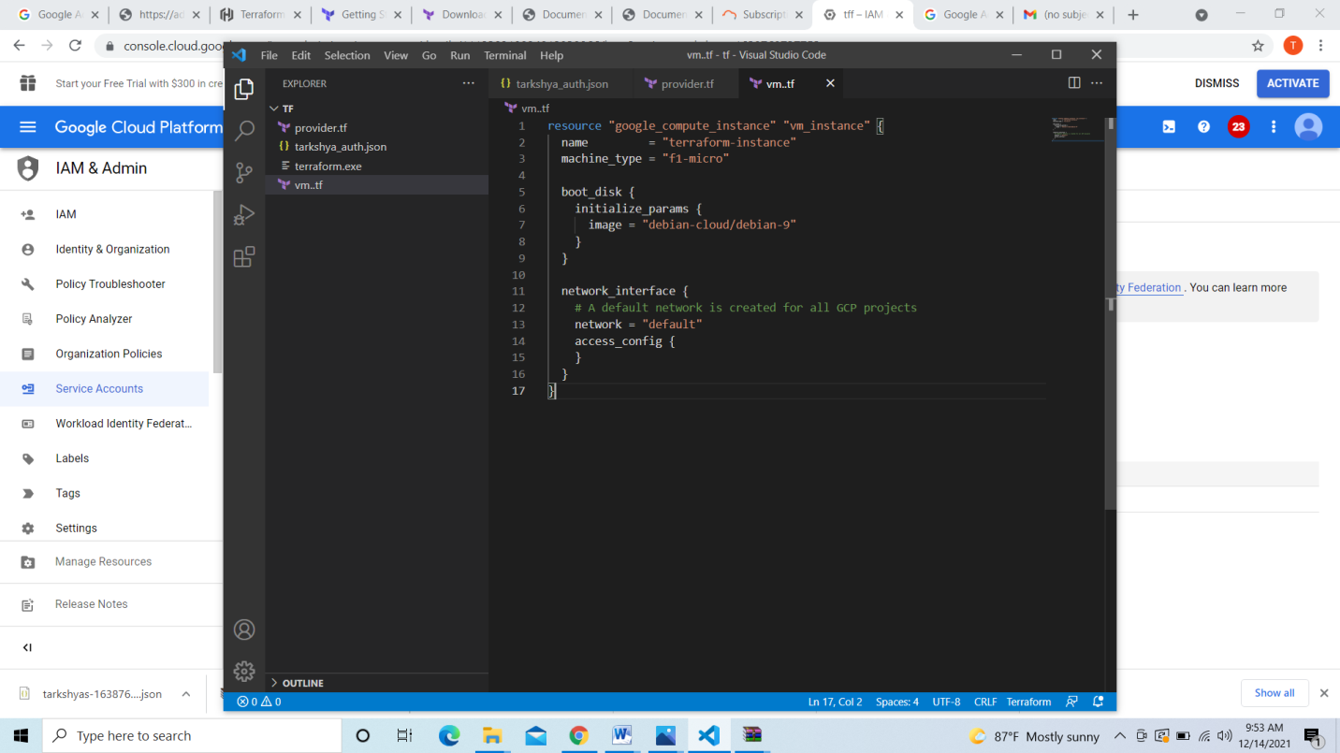

Create vm.tf file for creating the vm deploy in command promt select the path to the folder and enter the commands

>gcloud init

>terraform init

>terraform plan

>terraform apply

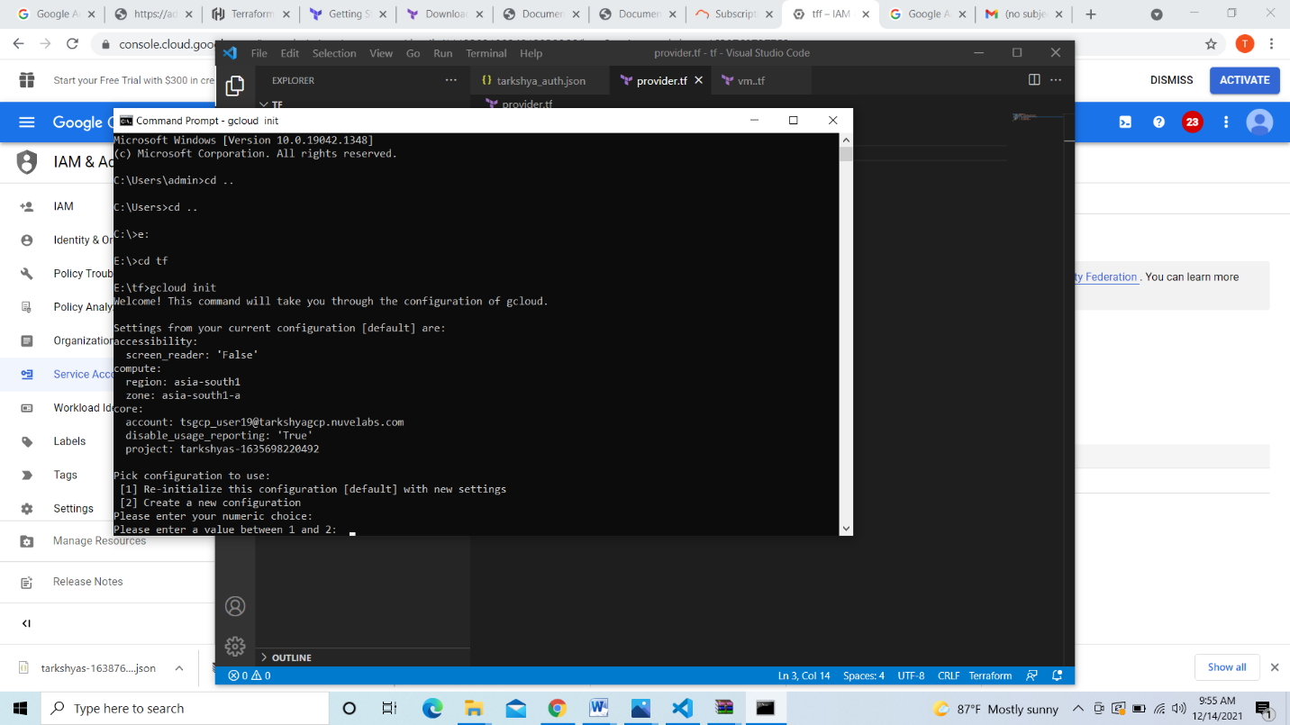

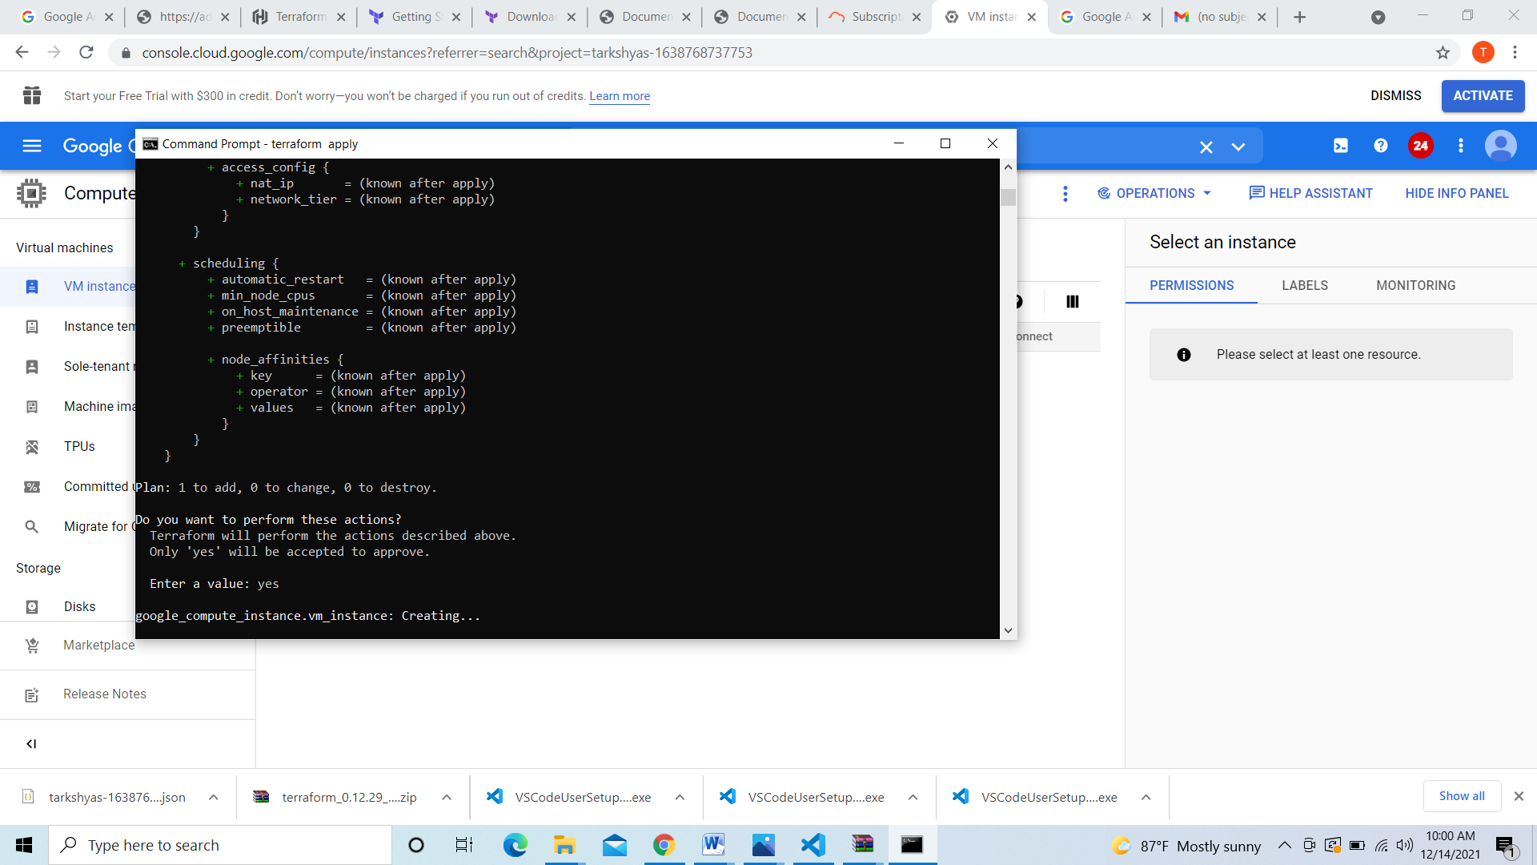

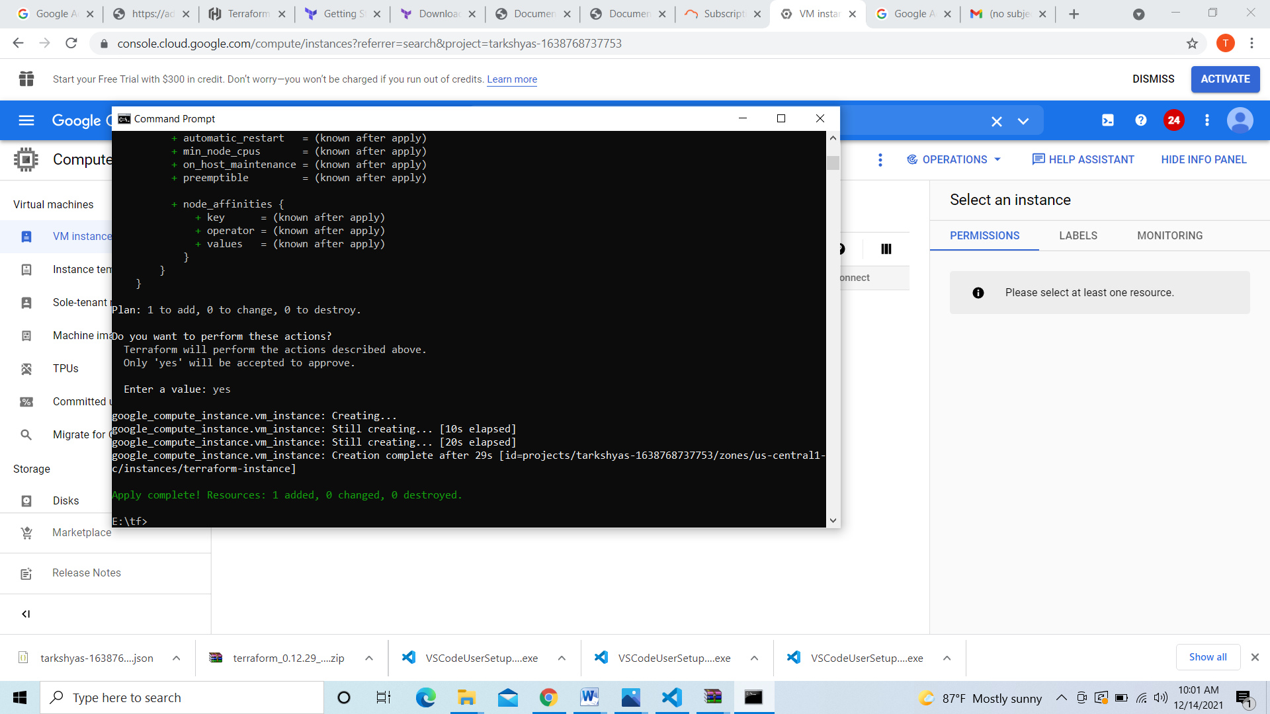

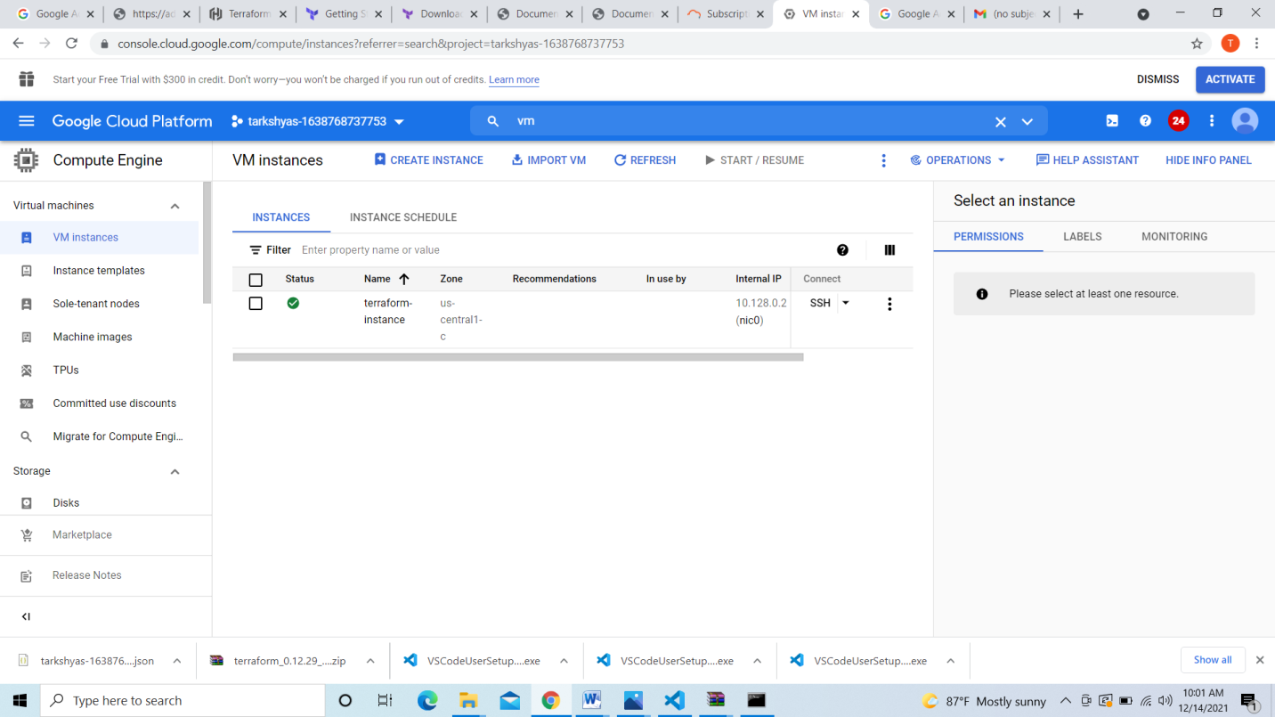

Created vm instance successfully

Now we can create sql database for that create file sql.tf as shown below

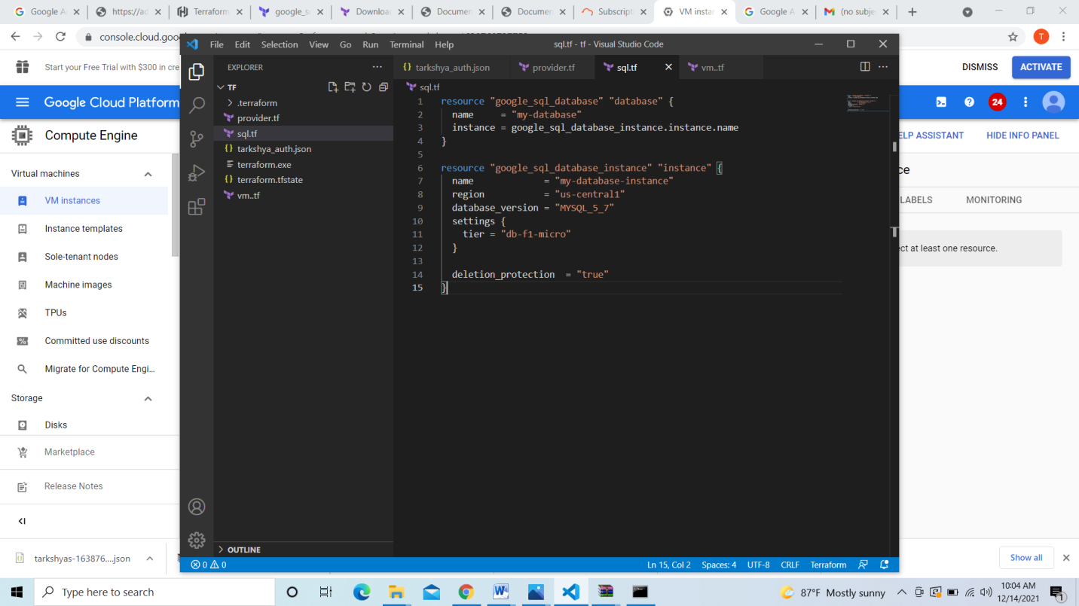

deploy in command promt select the path to the folder and enter the commands

>gcloud init

>terraform init

>terraform plan

>terraform apply

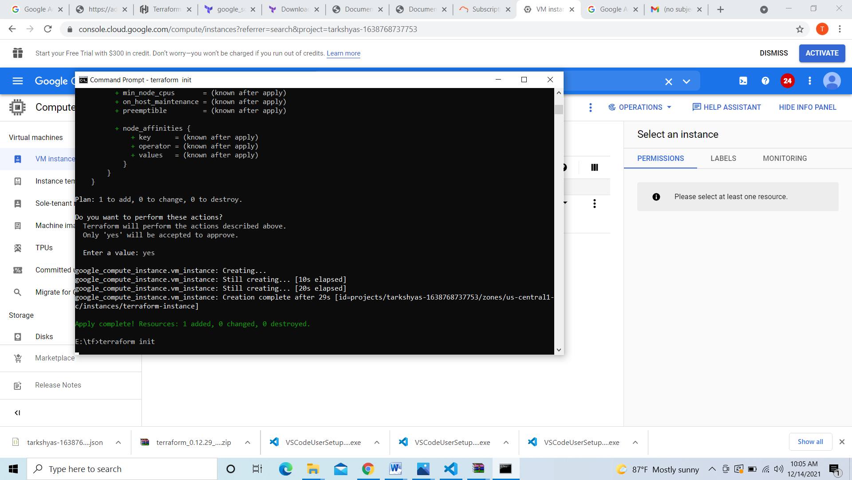

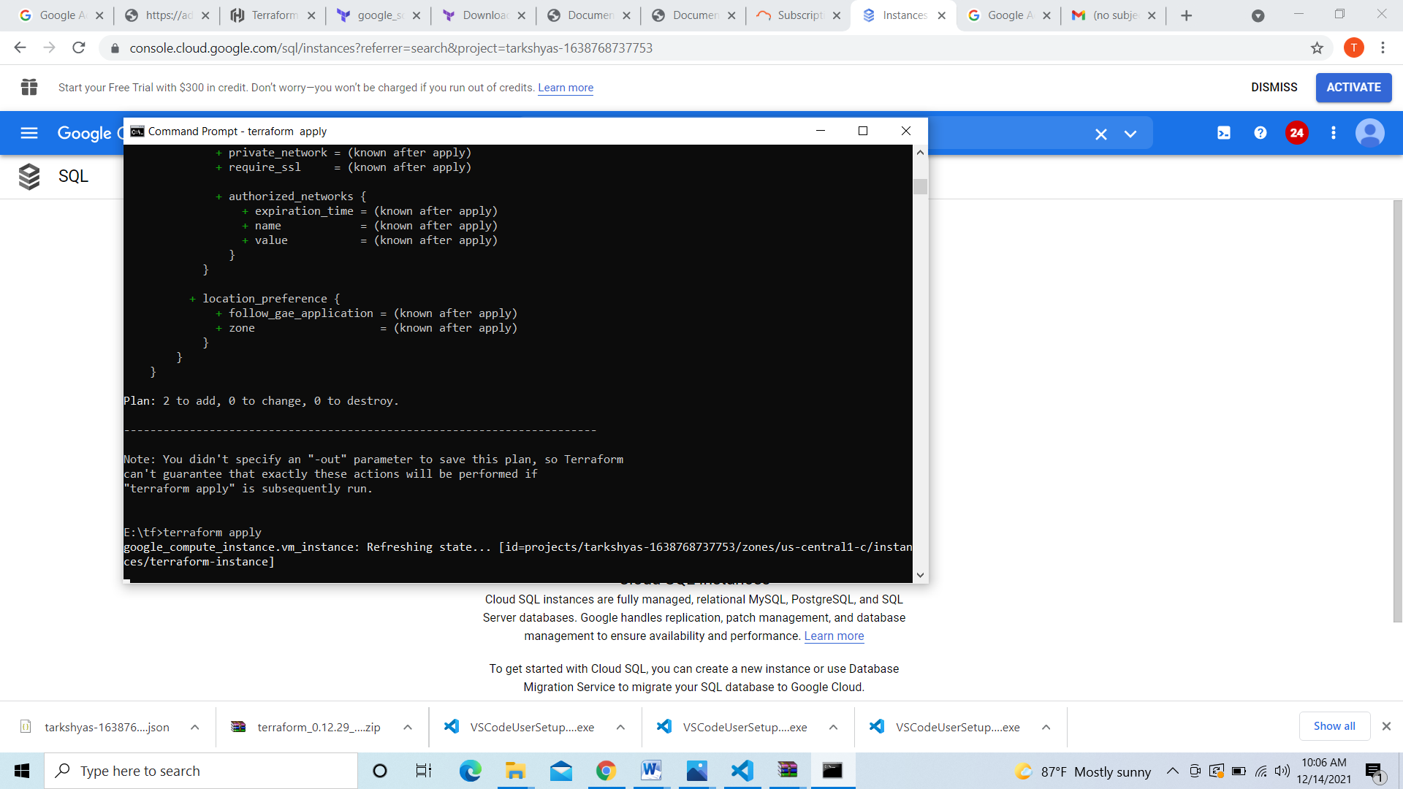

Enable cloud sql and cloud sql Admin API

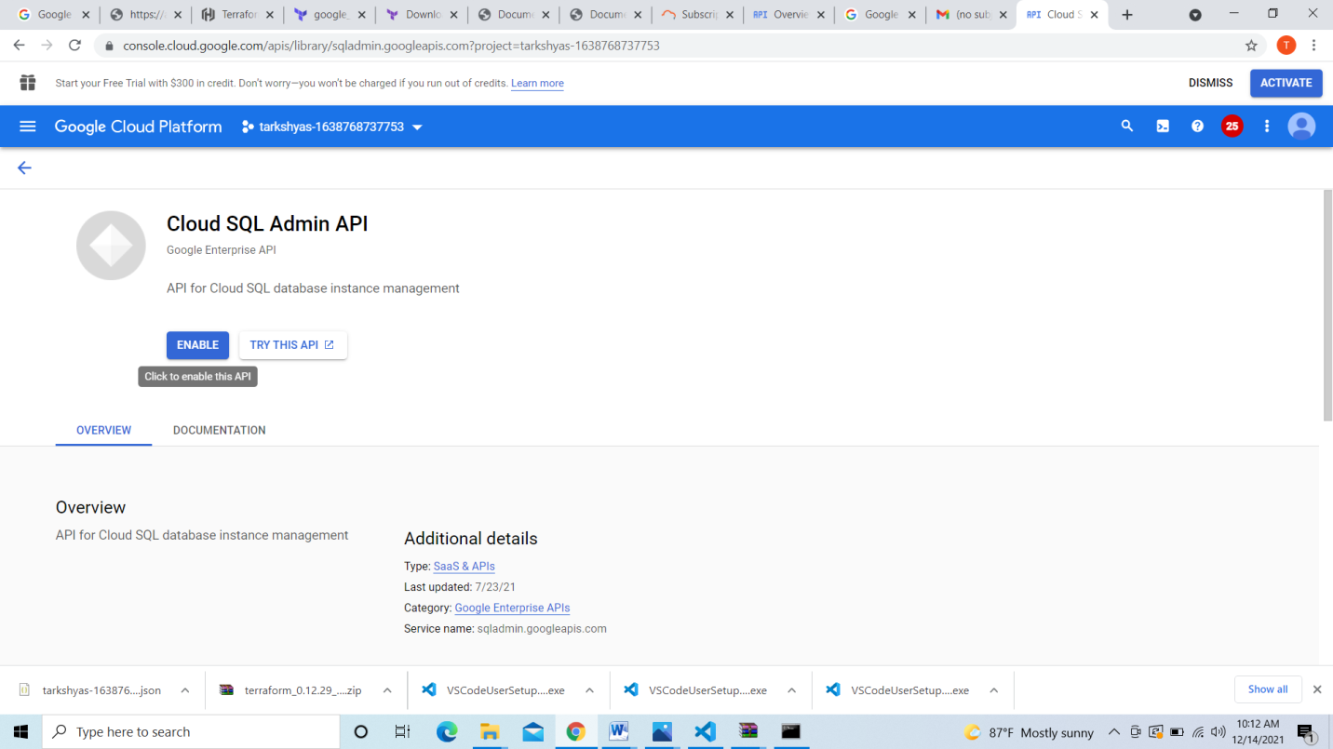

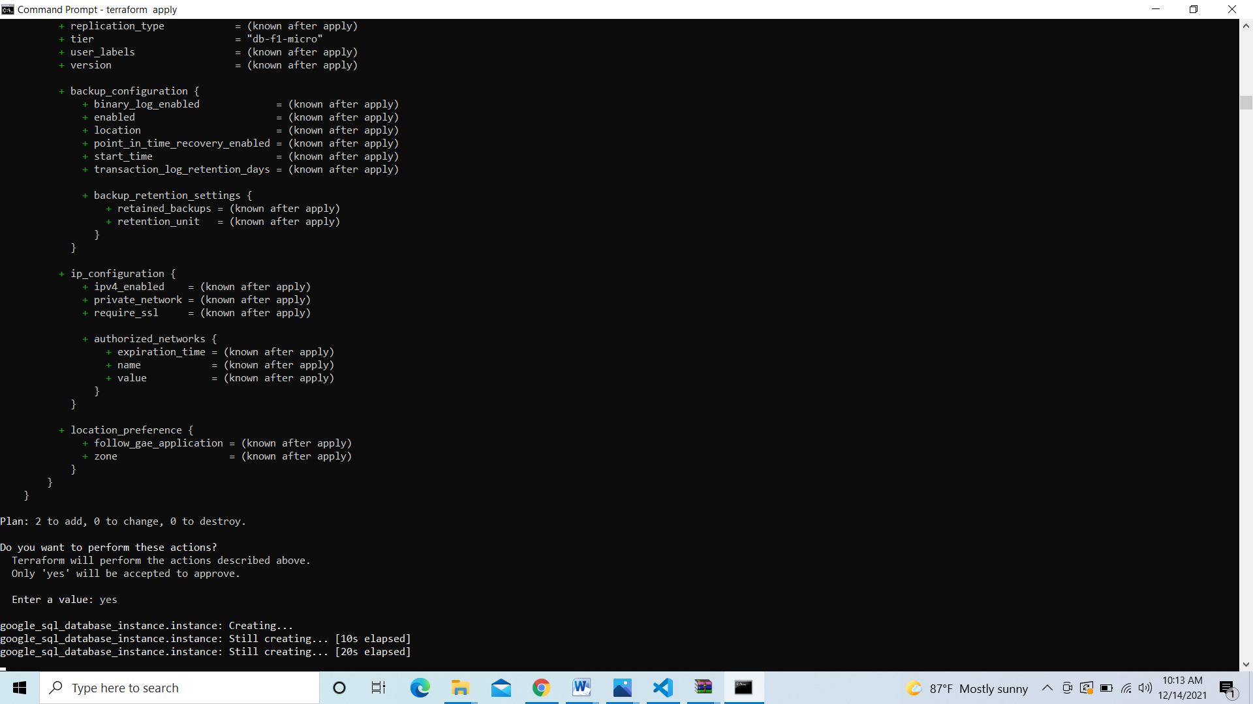

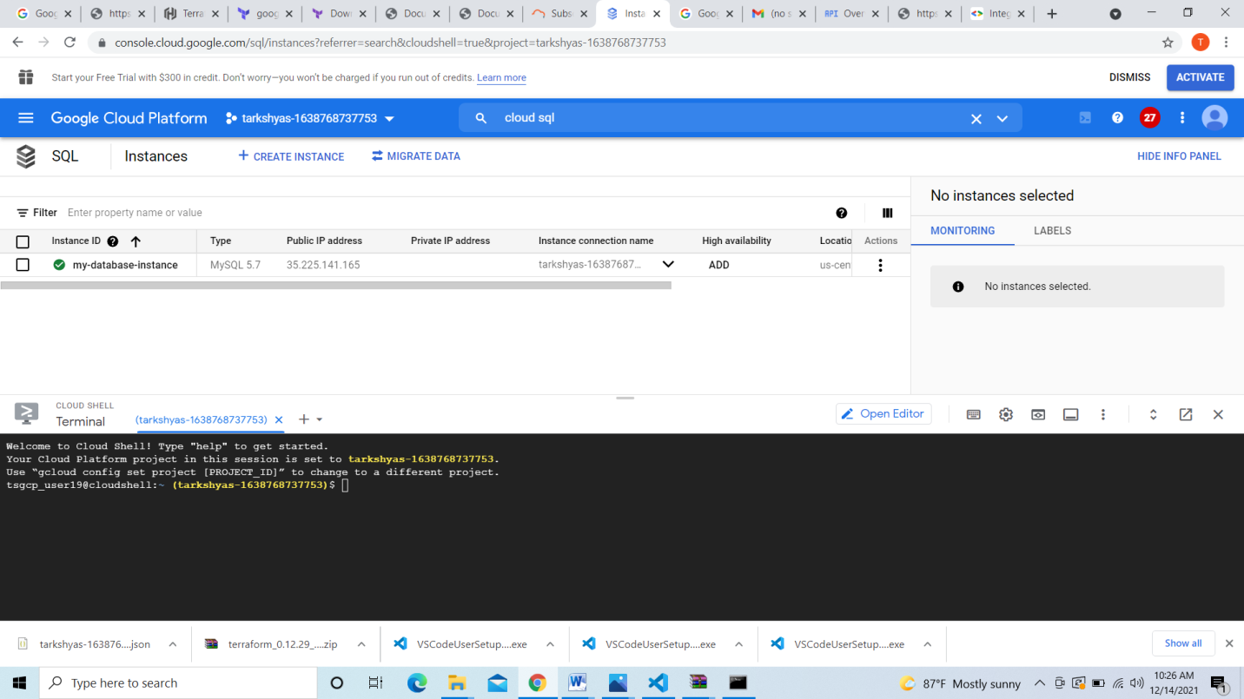

Here we can see cloudsql database is created

**8.Ansible**

>pip install ansible==2.9.0

>python –m install –-user ansible

>pip install requests google-auth

>ansible-playbook new.yml

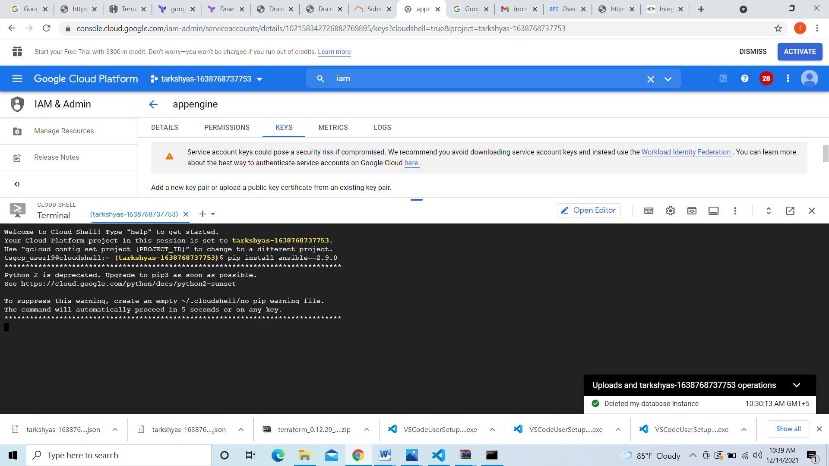

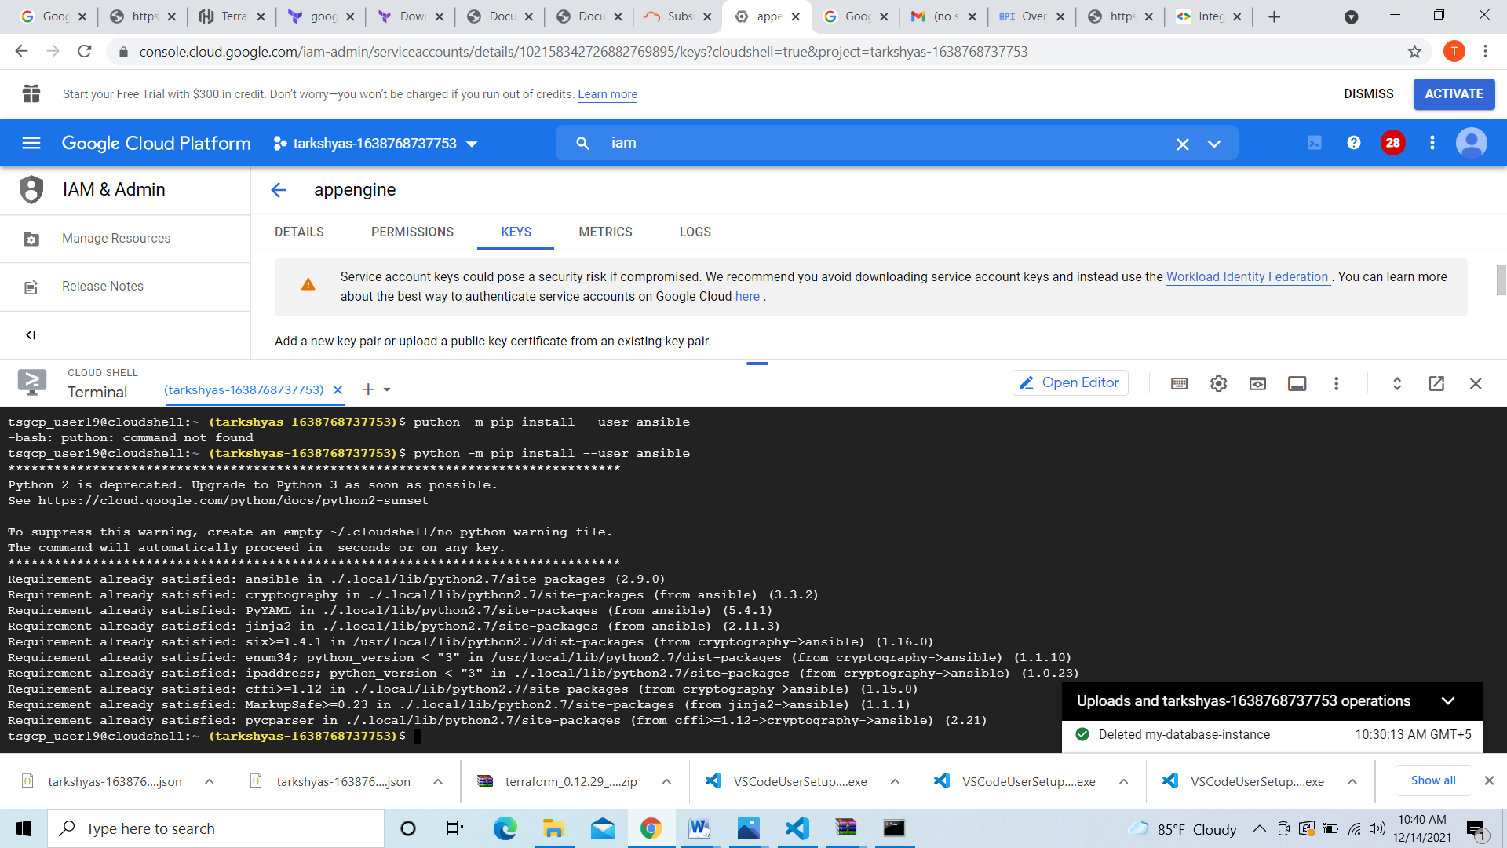

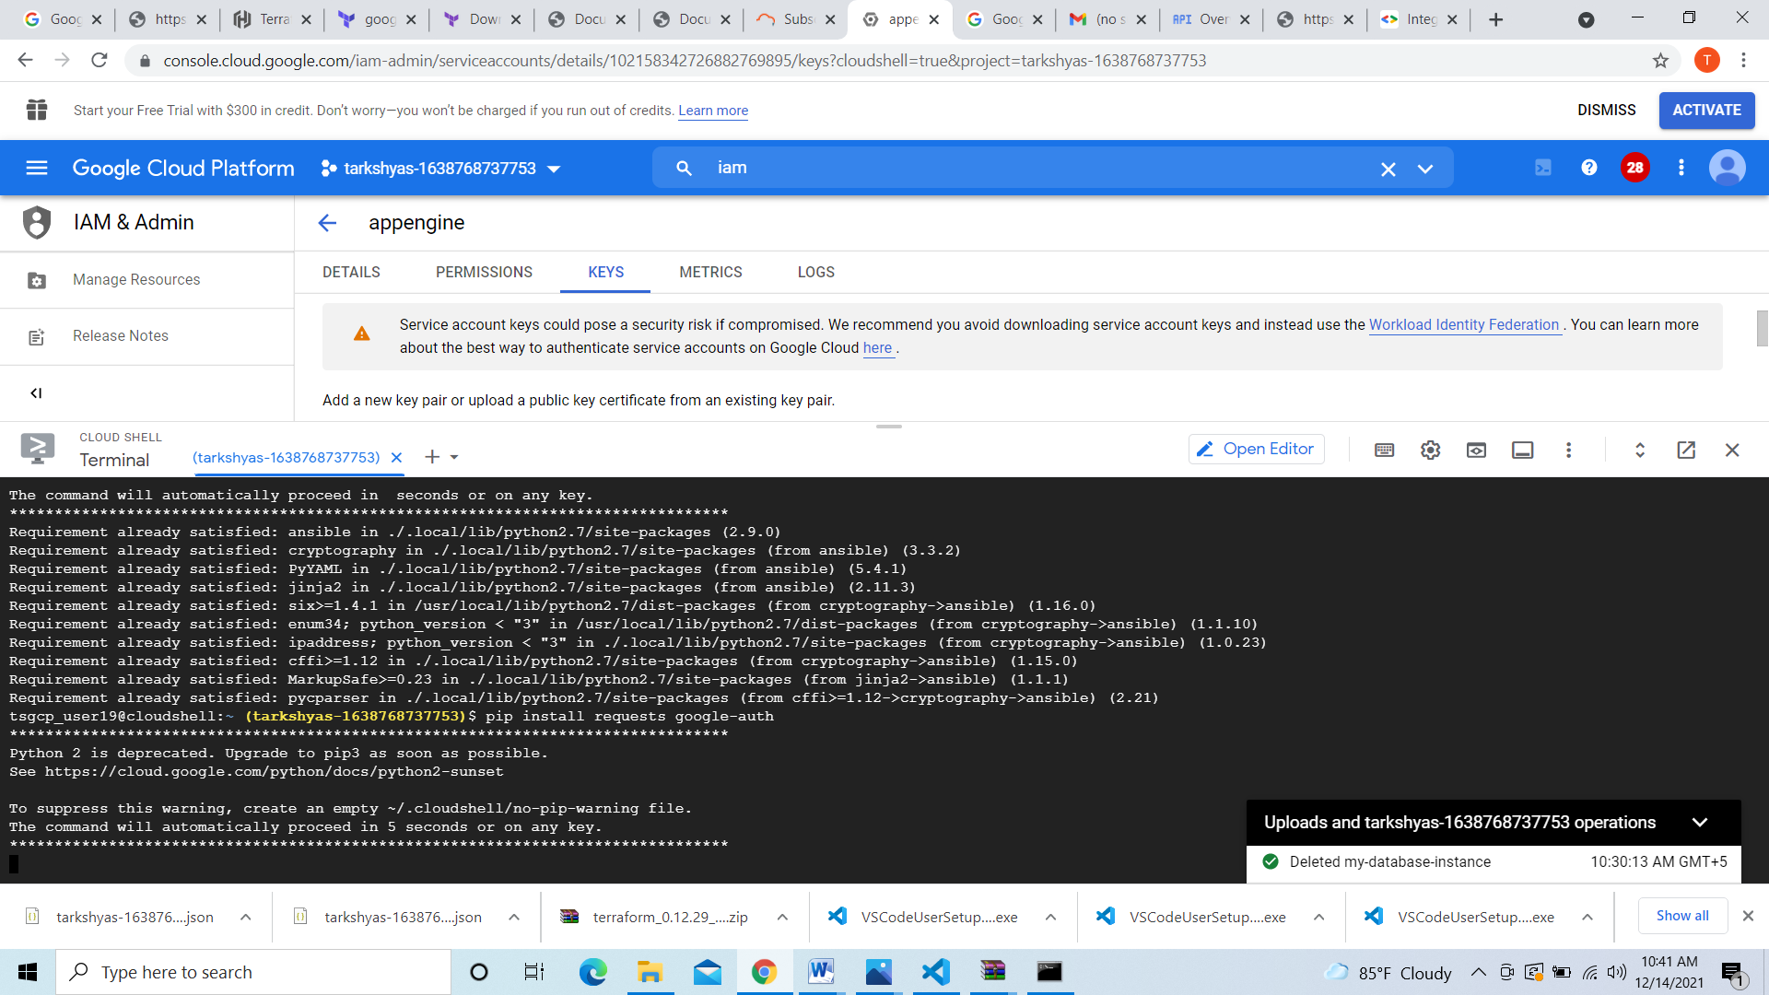

Upload service account key and new.yml file which contains codes for creating vm

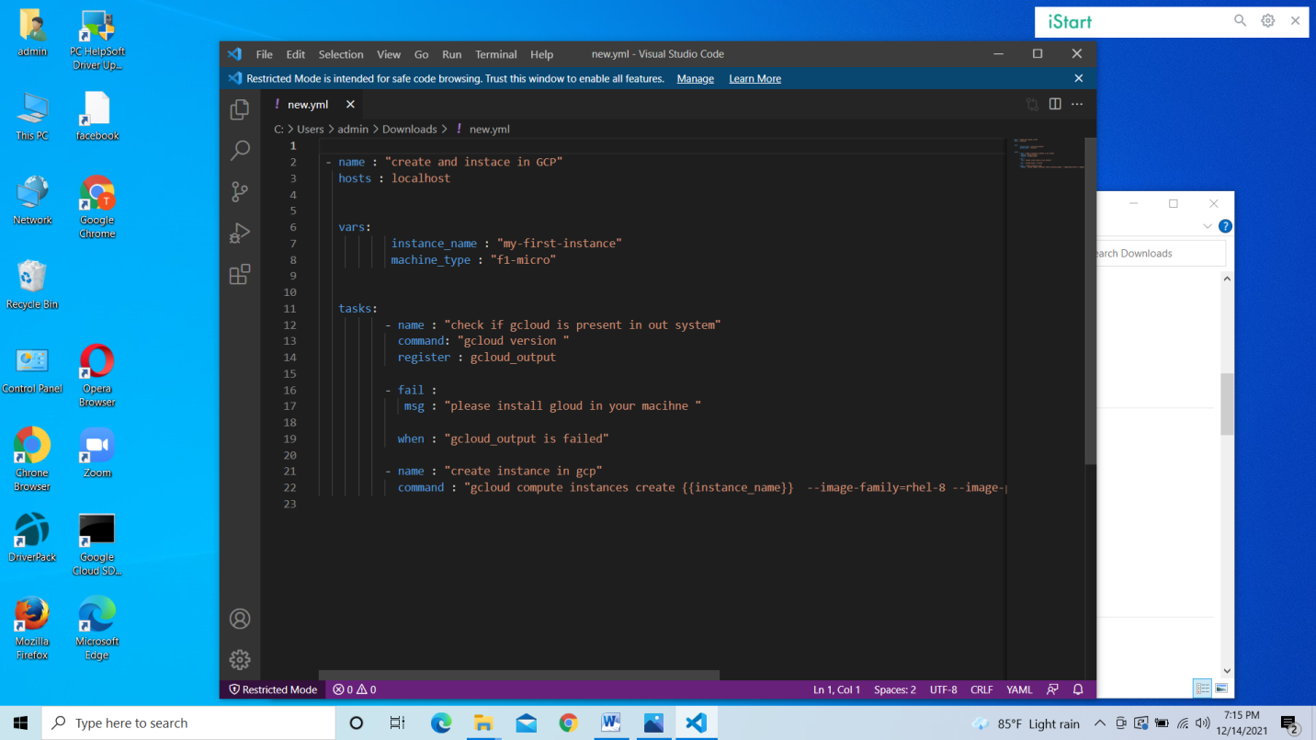

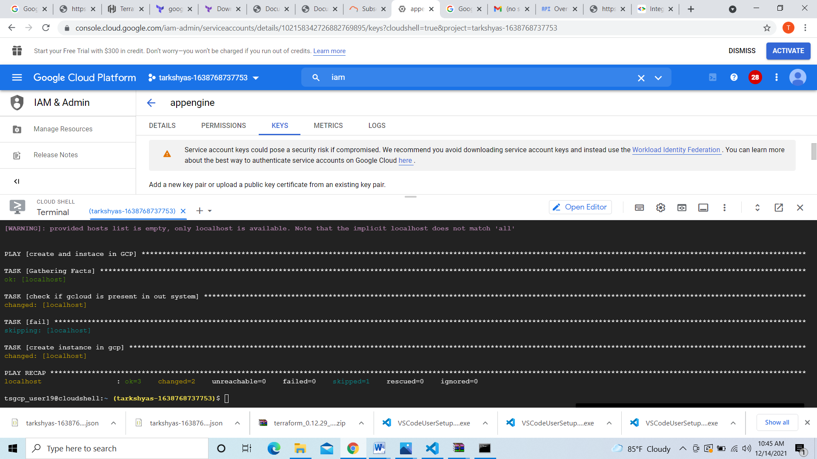

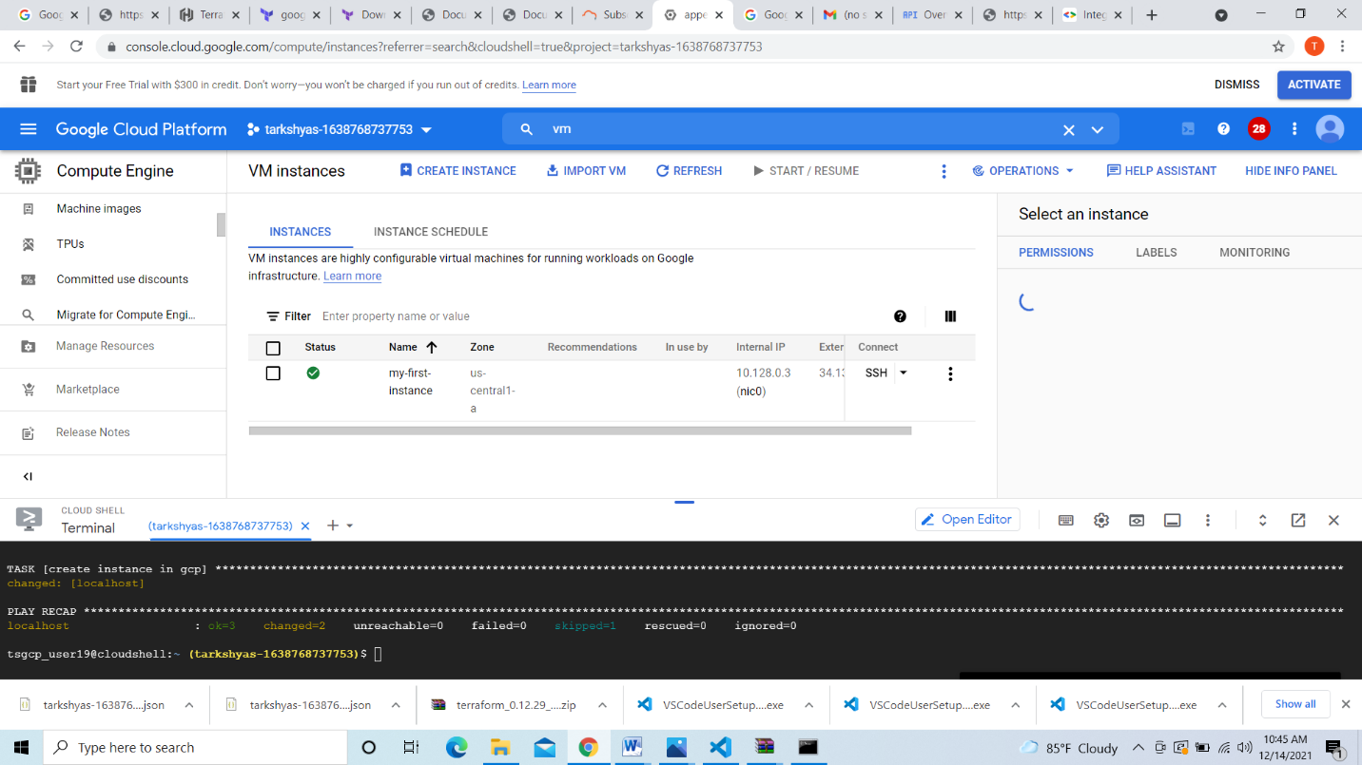

Created vm instance successfully.

**9.BIGQUERY**

Understanding the concepts of BigQuery and Cloudstorage,SQL basics [WHERE,GROUP BY, JOIN TABLES]

Create dataset select region here I used dataset of crimes from e-commerce dataset

Create dataset

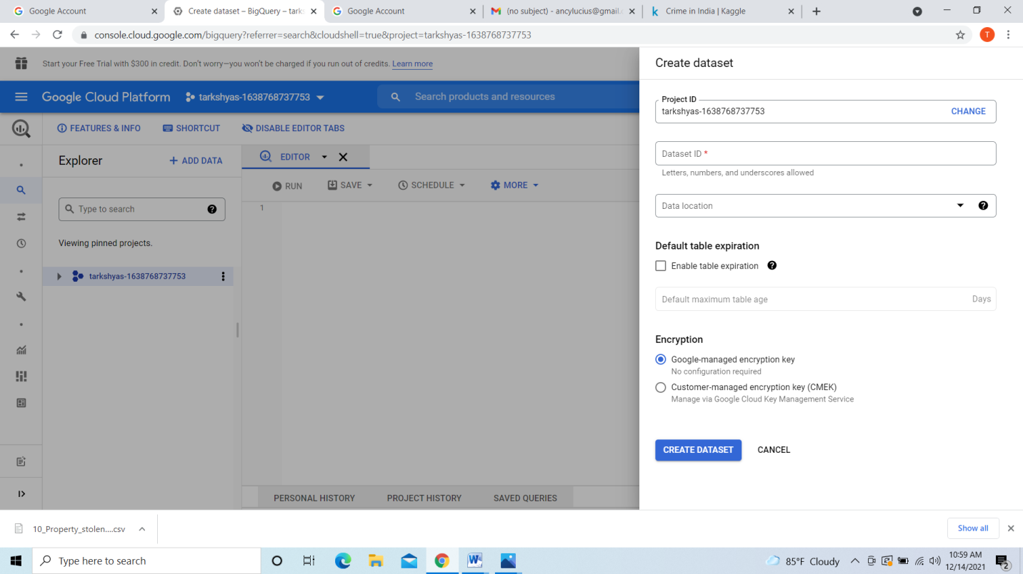

Create table upload file from the pc

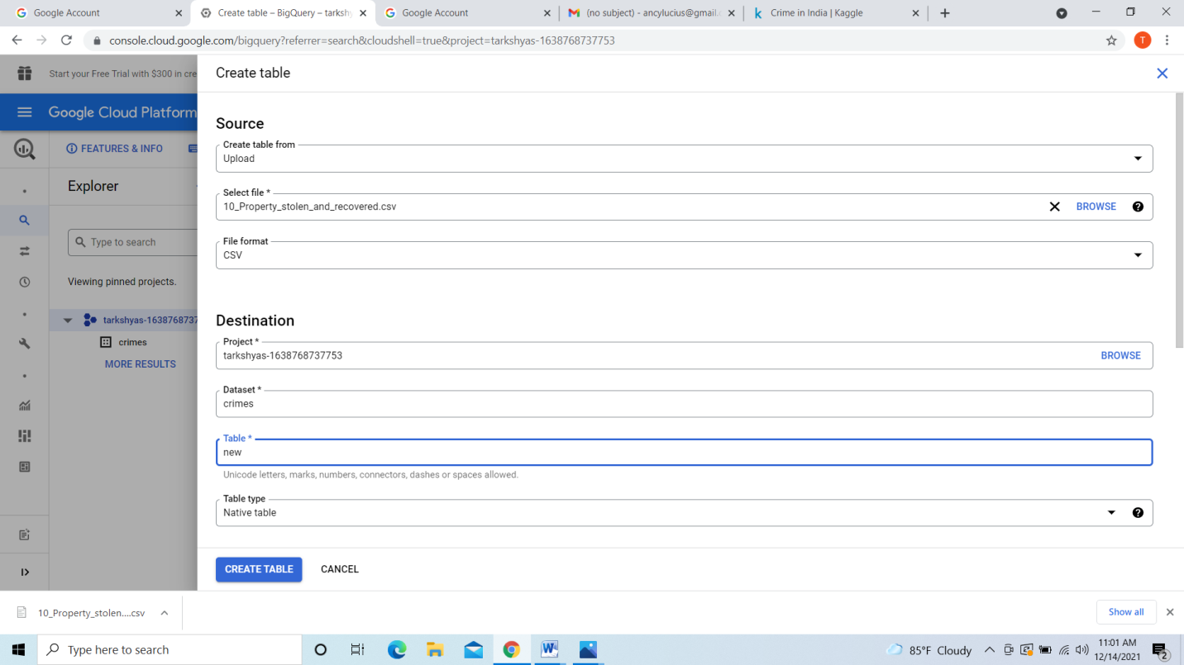

Here the details of the table is shown below

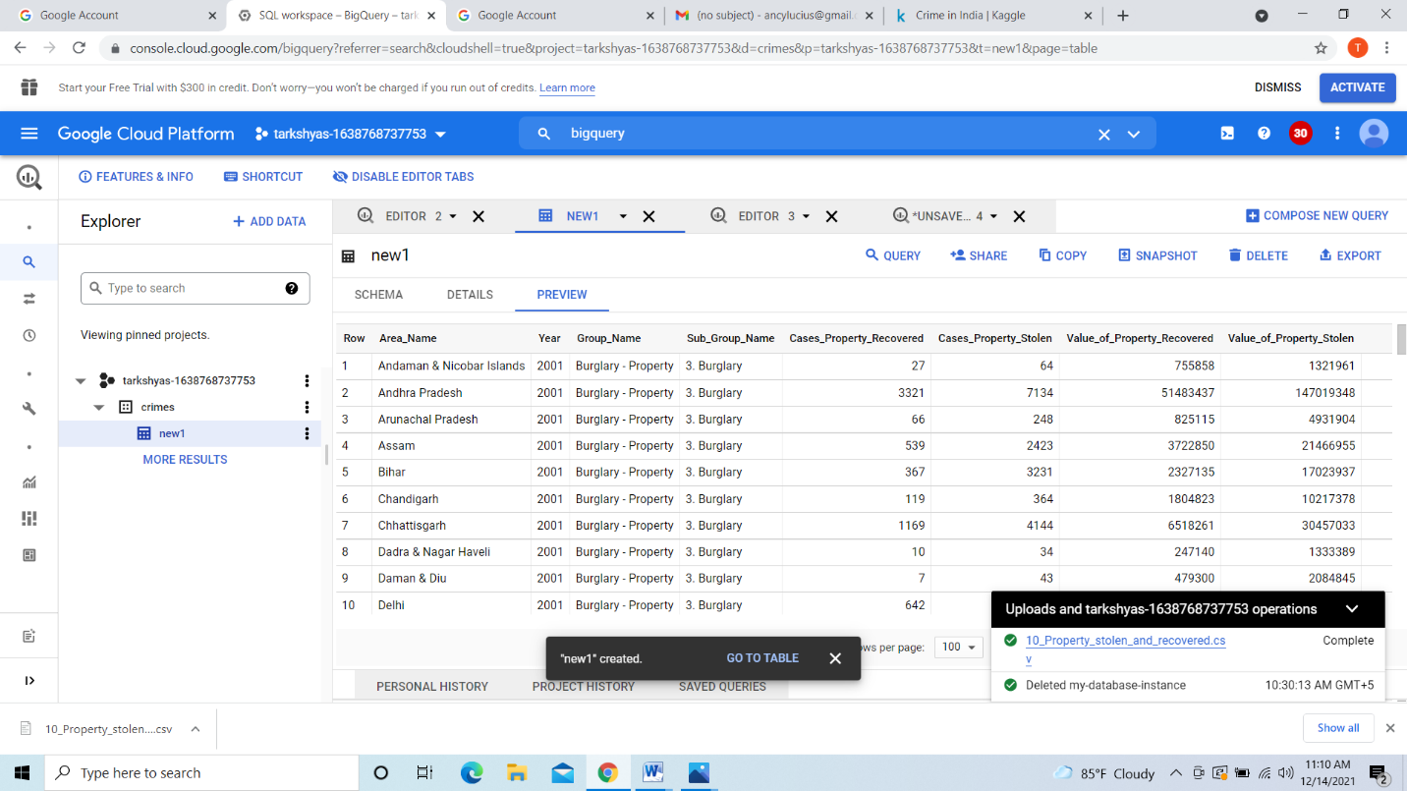

we can upload the same file from **cloud storage** also in Bigquery

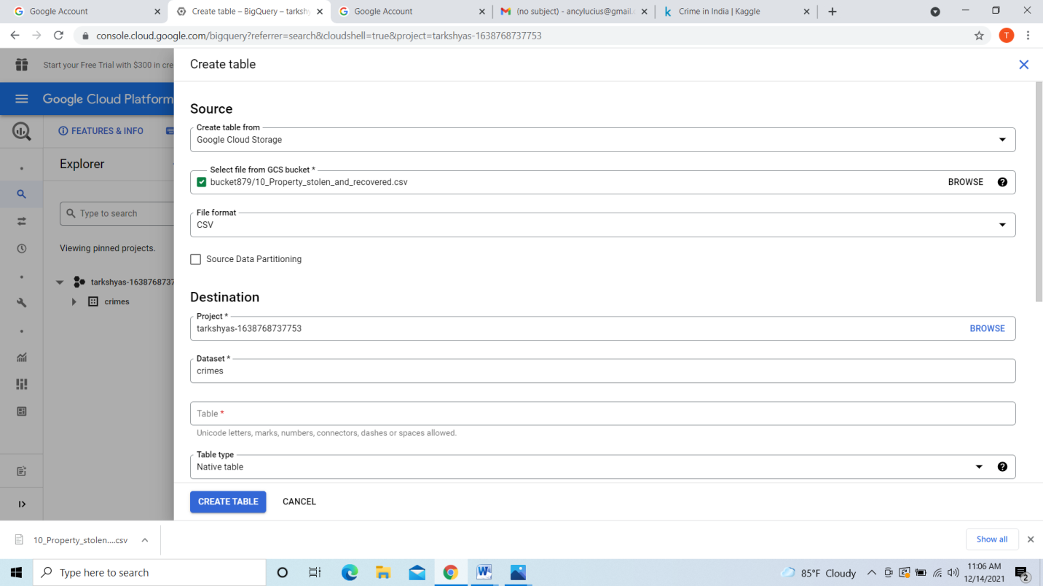

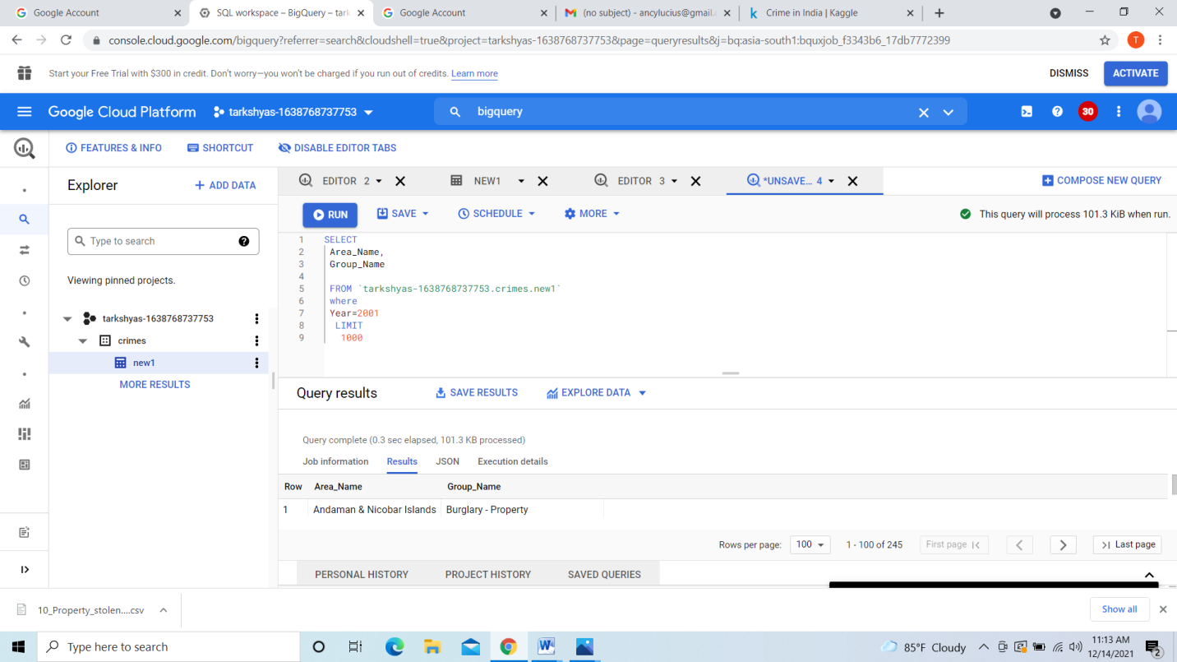

Use the **WHERE** command in the query as shown above

Here I uploaded another file with different dataset as shown below

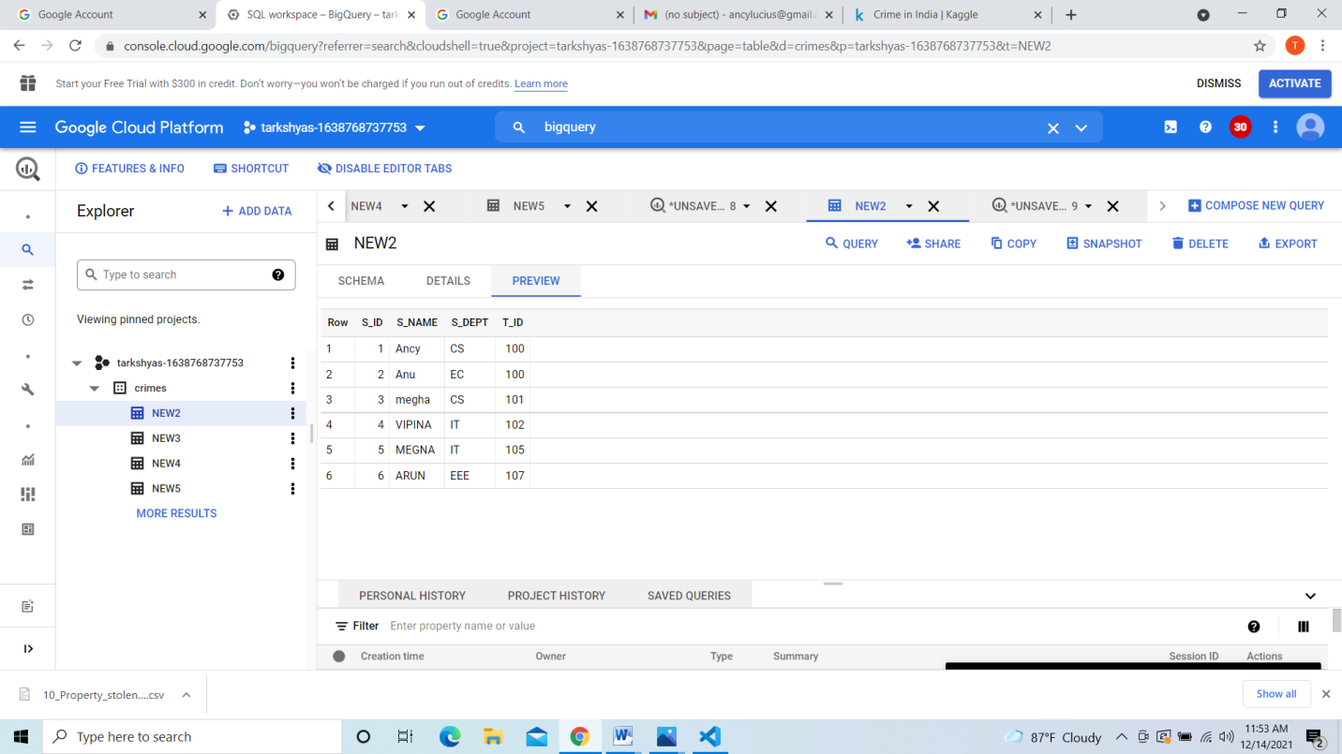

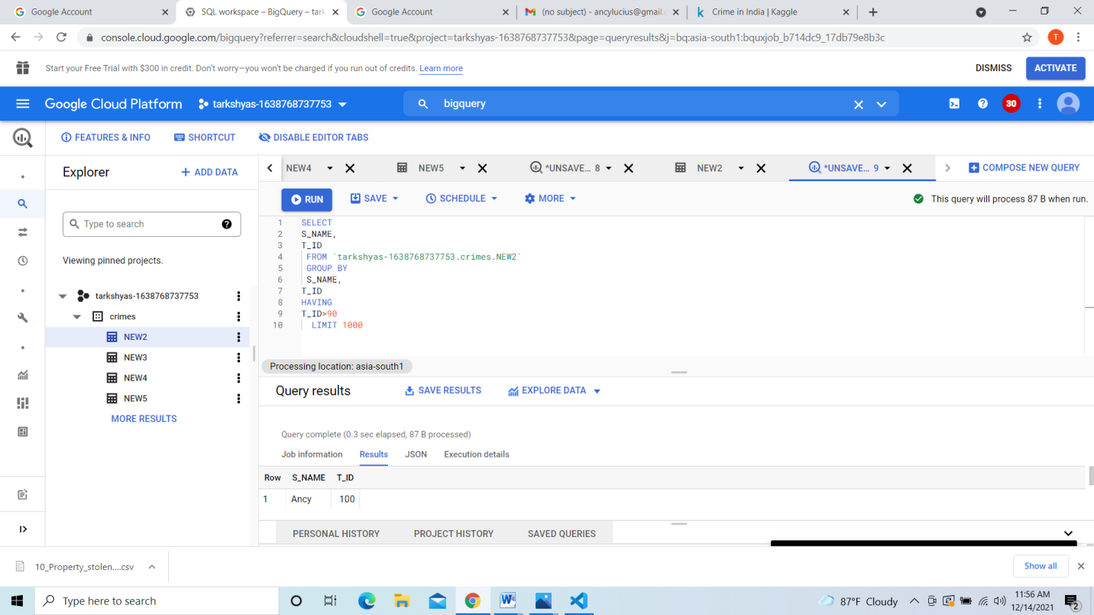

Here I used **group by** command in the query as shown above

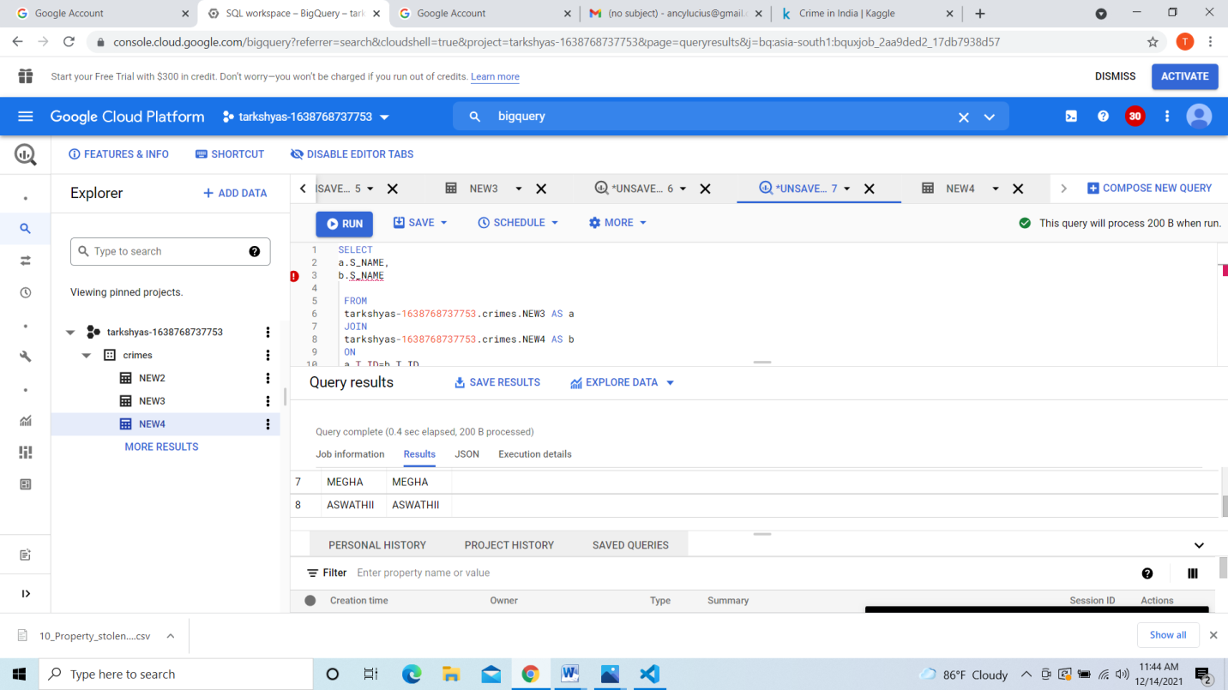

We can append table to another table here the **count** before appending the table shown below

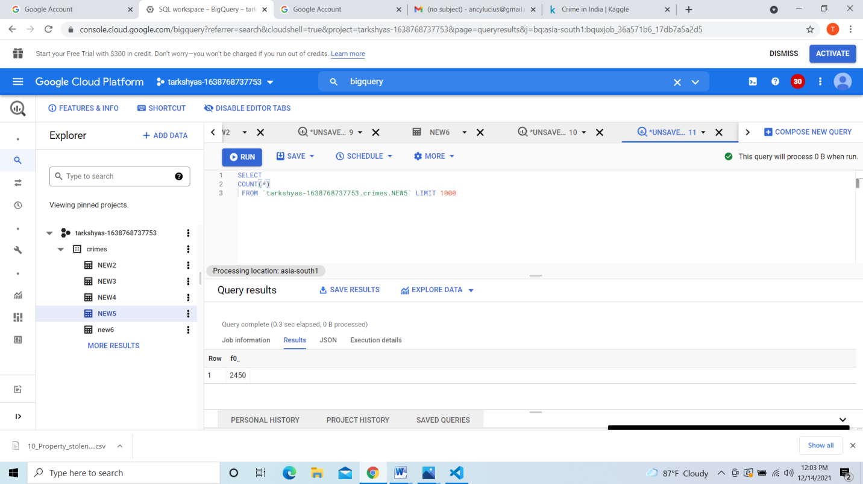

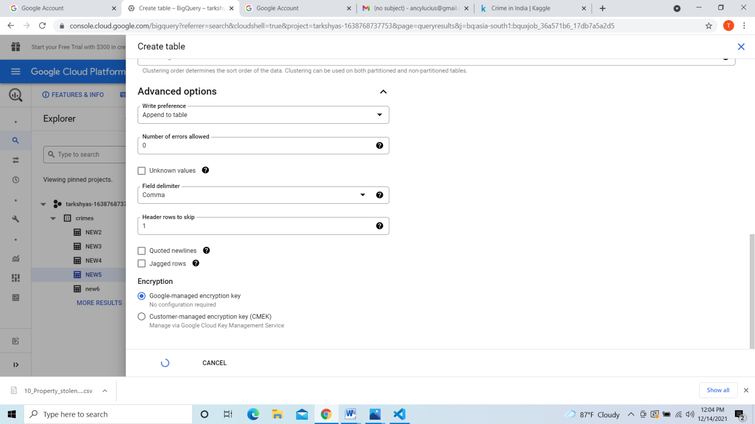

After appending table having same count to previous table we can check it by looking count it becomes twice the previous count as shown below:

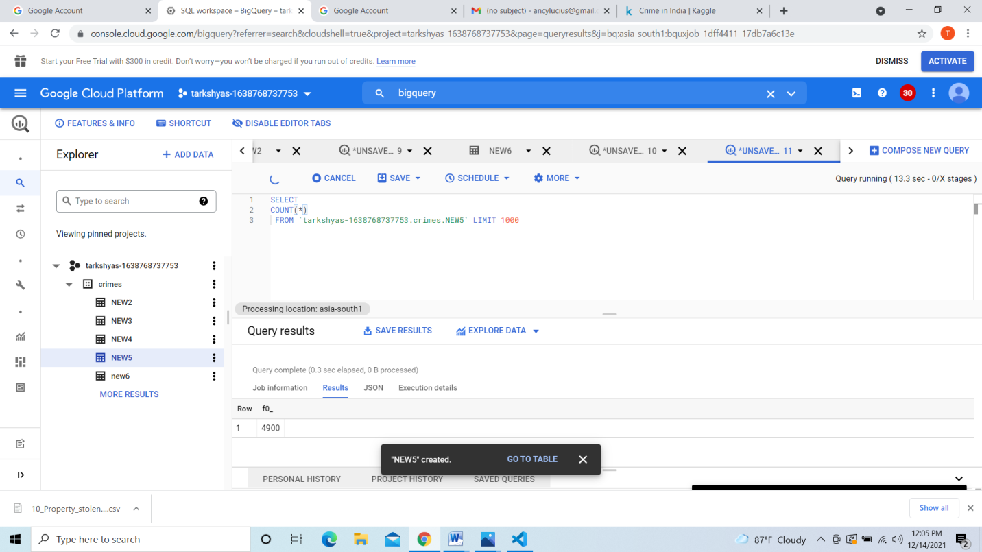

**Partitioned tables,clustering**

Here I used hacker file from e-commerce dataset

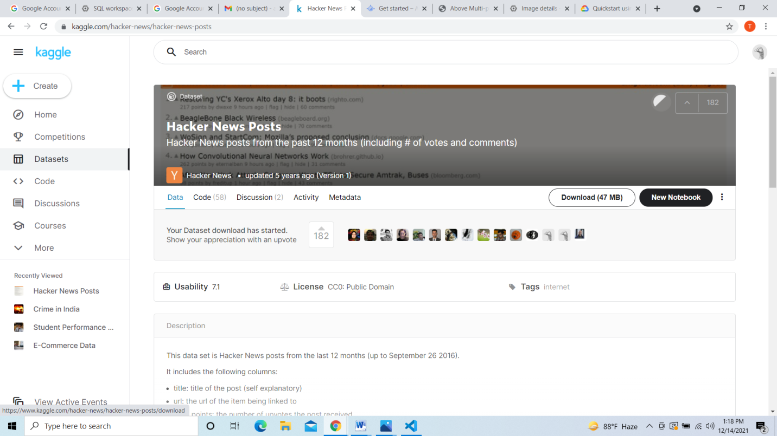

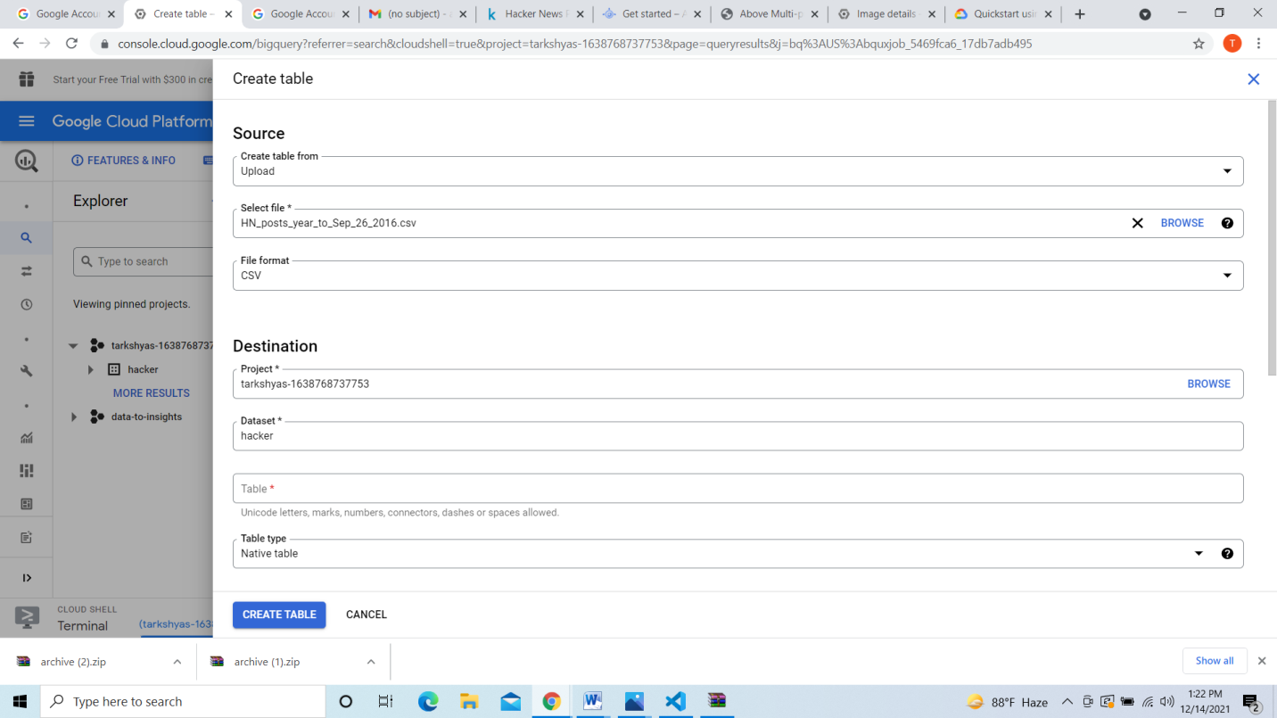 The data of hackers file is shown below

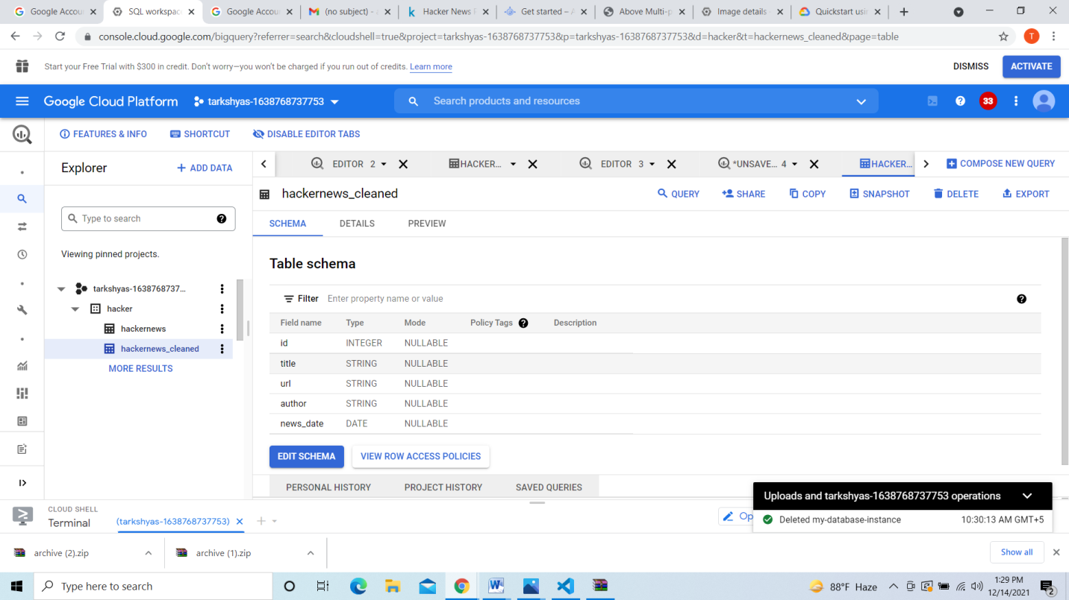

Here I used **create or replace** command for creating new table hackernews_cleaned from table hackernews

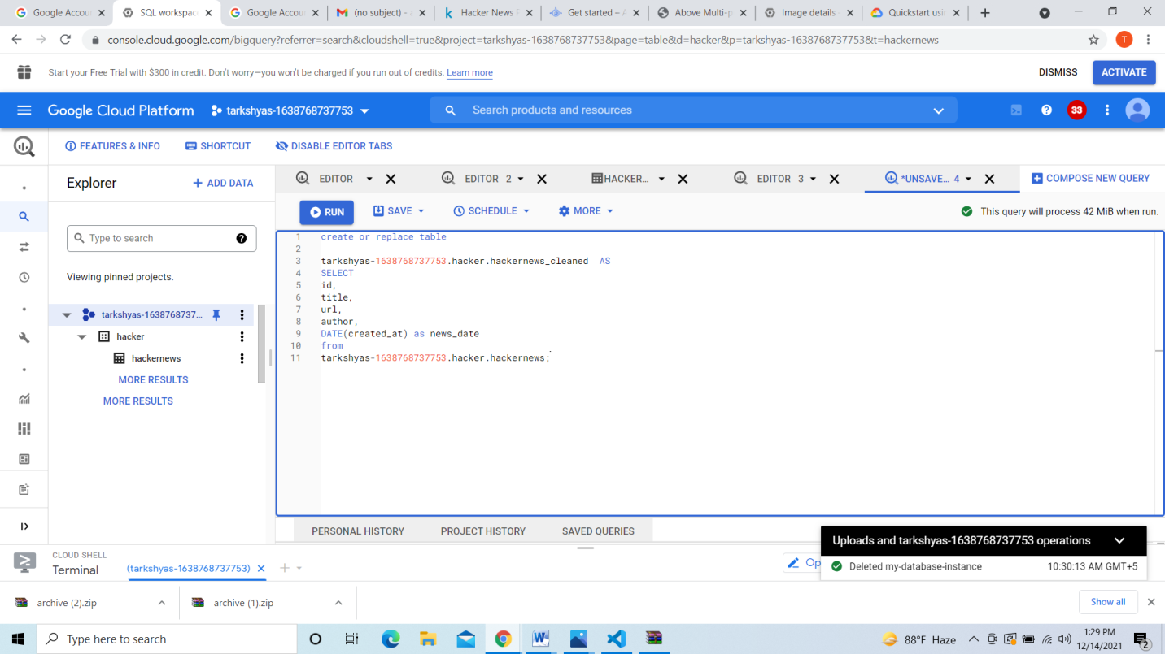

Here I used **partition** command for partioning table and creating a new table hackers_cleaned_partitioned from hackers_cleaned

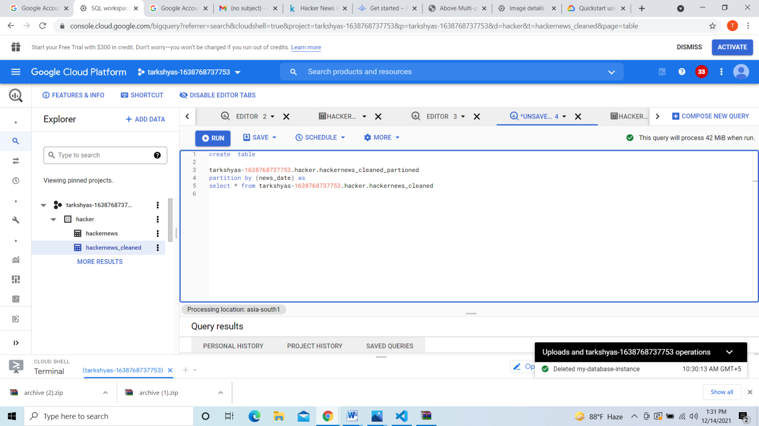

Here is the table created below hackersnews_cleaned_partitioned by partitioning from hackersnews_cleaned

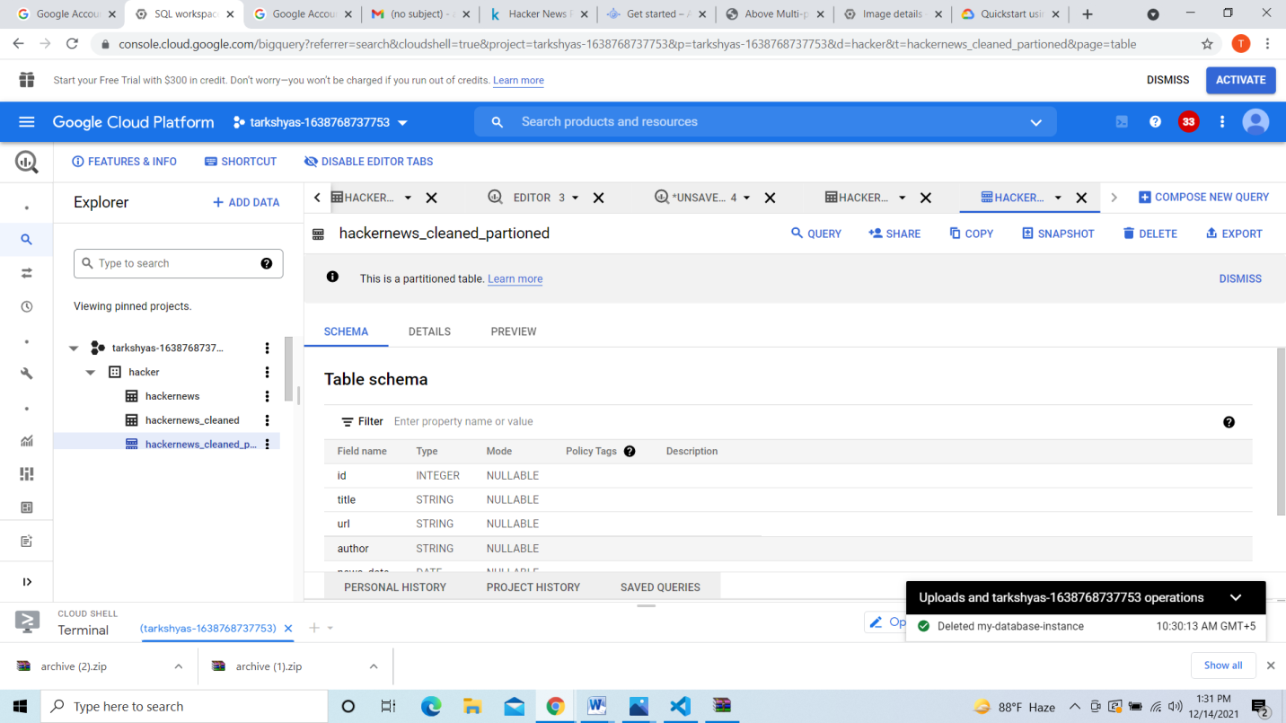

Here in the below screenshot I used **cluster** command for clustering hackernews_cleaned to hackernews_cleaned_partitioned_

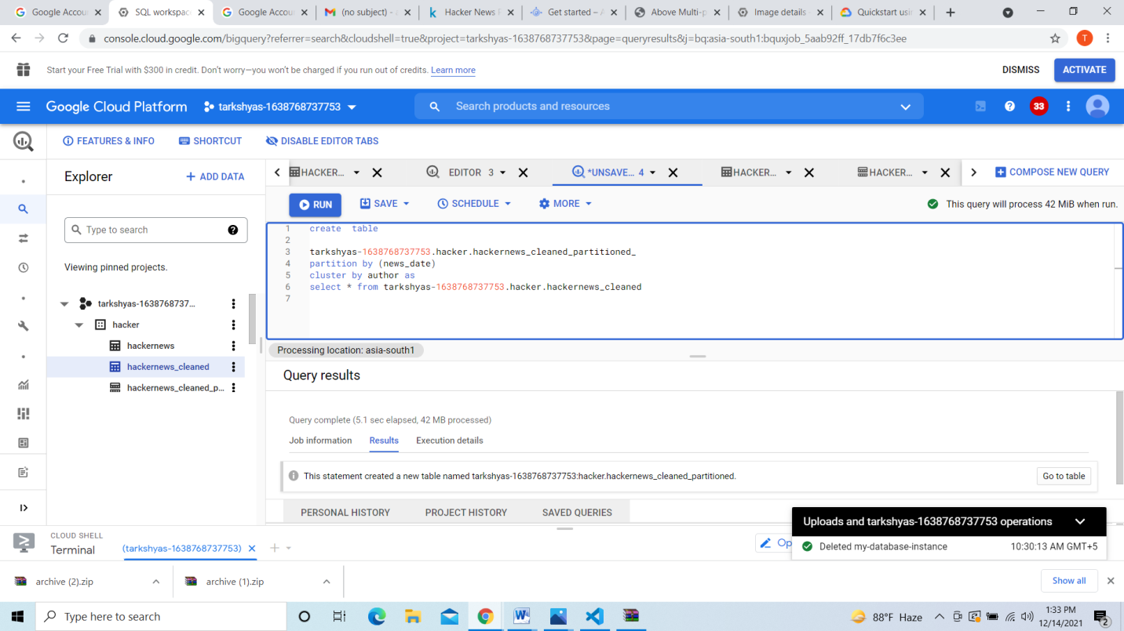

Here is the table created below

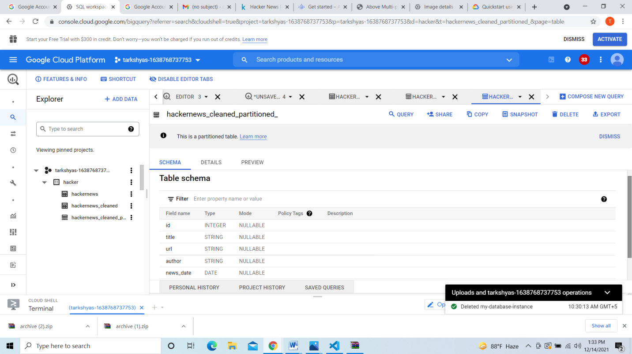

Below screenshot I had Created new table by partition and clustering from hackernews_cleaned to hackernews_partitioned_clustered

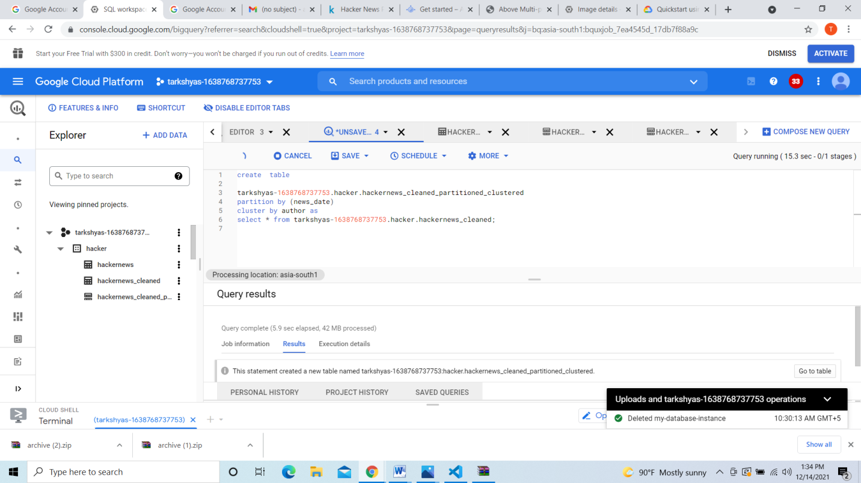

Here below I selected news_date between particular dates from table hackernews_clean_partioned_clustered

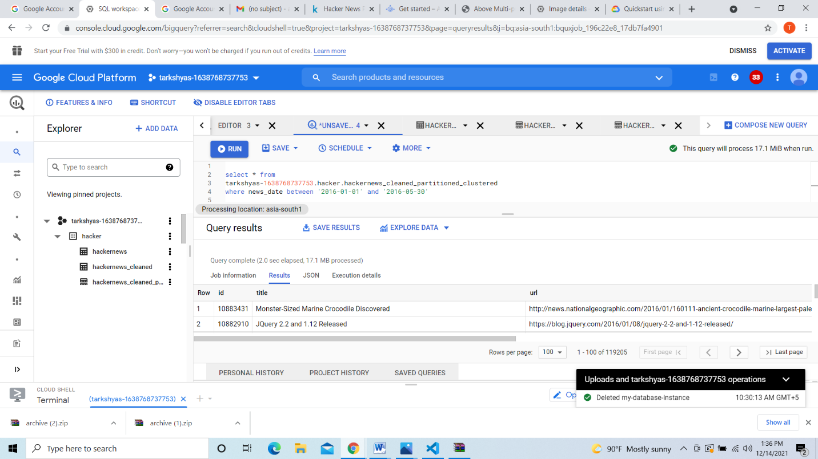

**Machine learning**

Machine learning can be done by using the codes in the page given below:

[**https://www.qwiklabs.com/focuses/1794?parent=catalog**](https://www.qwiklabs.com/focuses/1794?parent=catalog)

click on this link below directs to the data set:

* <https://console.cloud.google.com/bigquery?p=data-to-insights&d=ecommerce&t=web_analytics&page=table>
* Here is the dataset shown in the screenshot below:

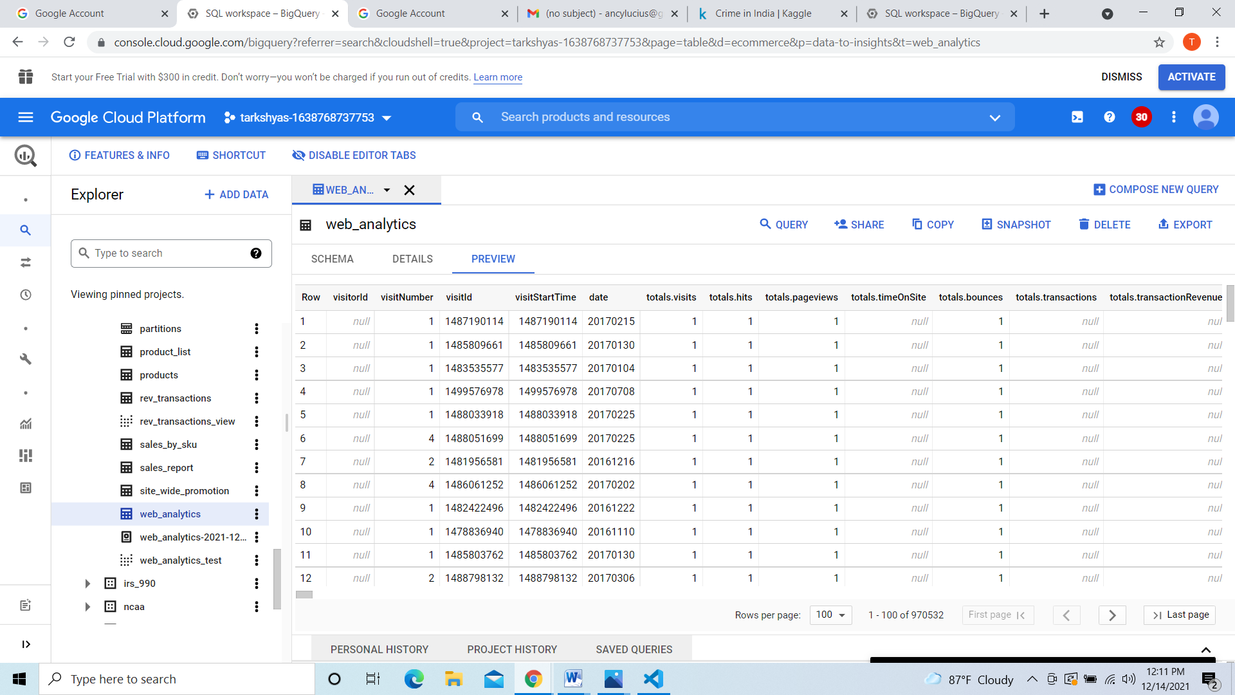

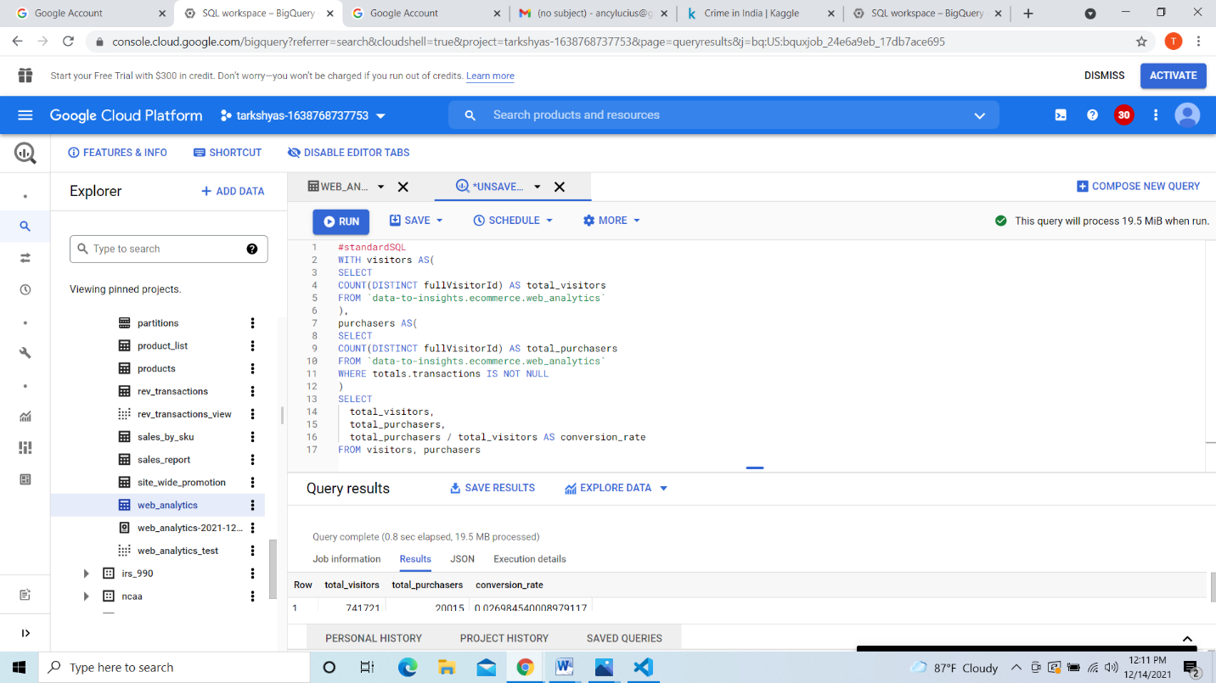

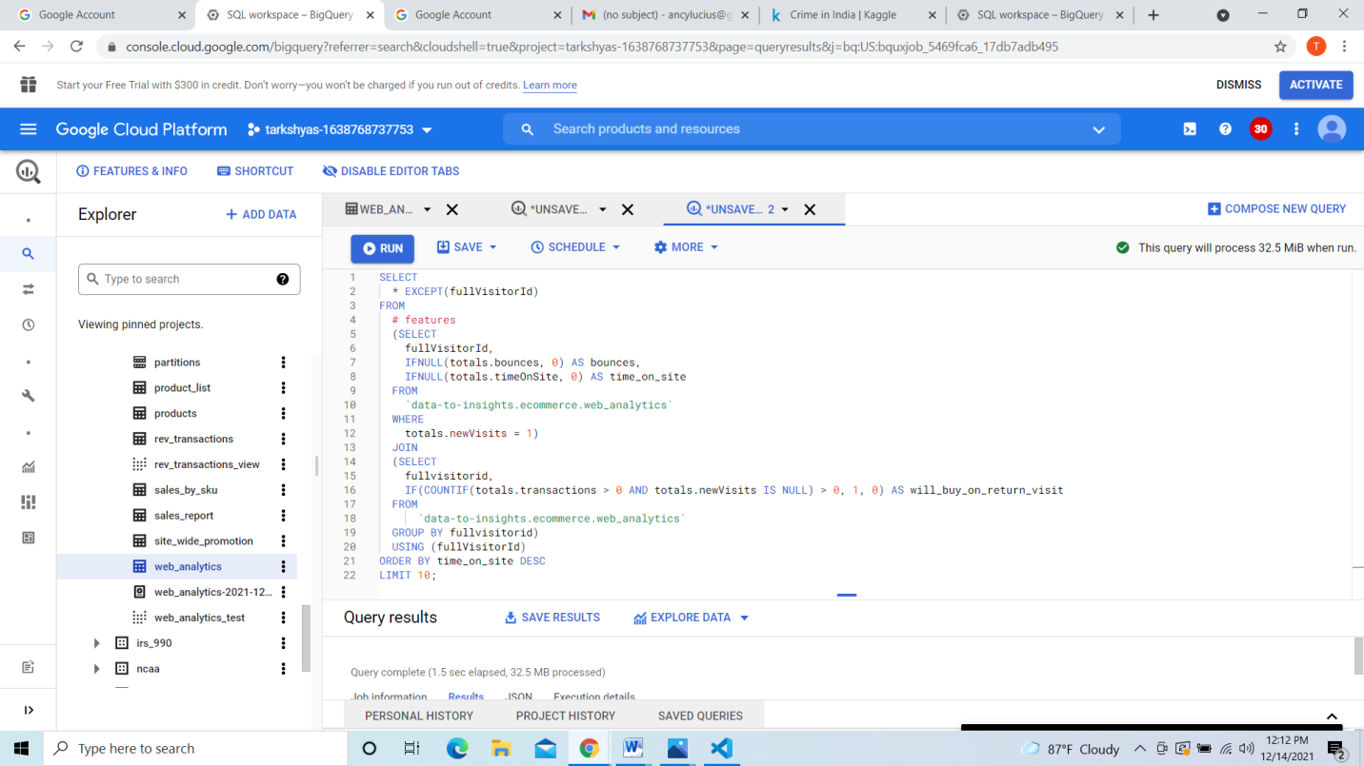

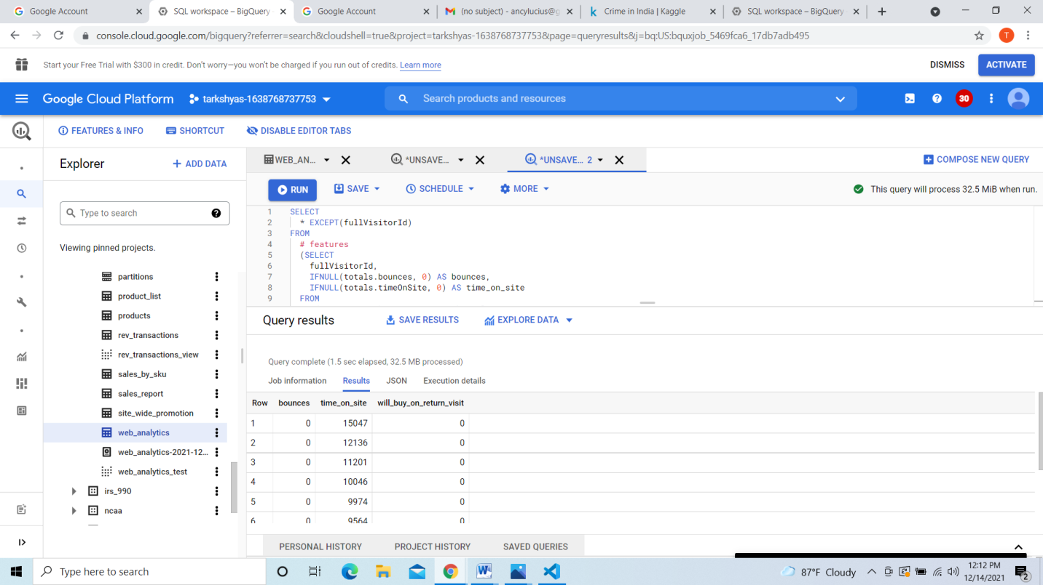

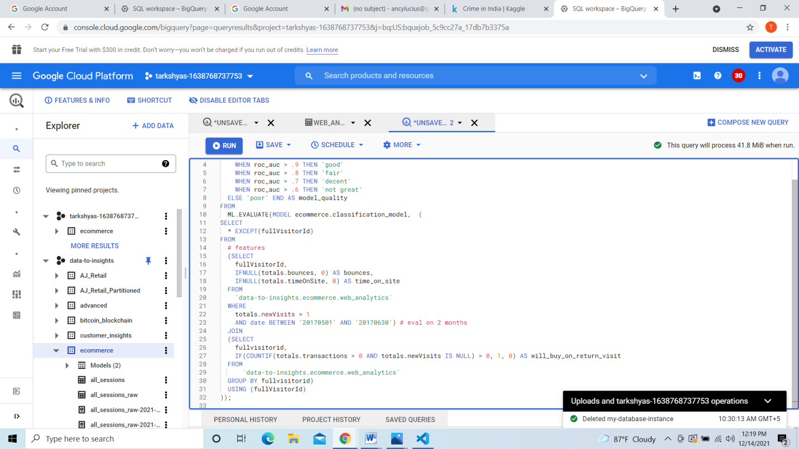

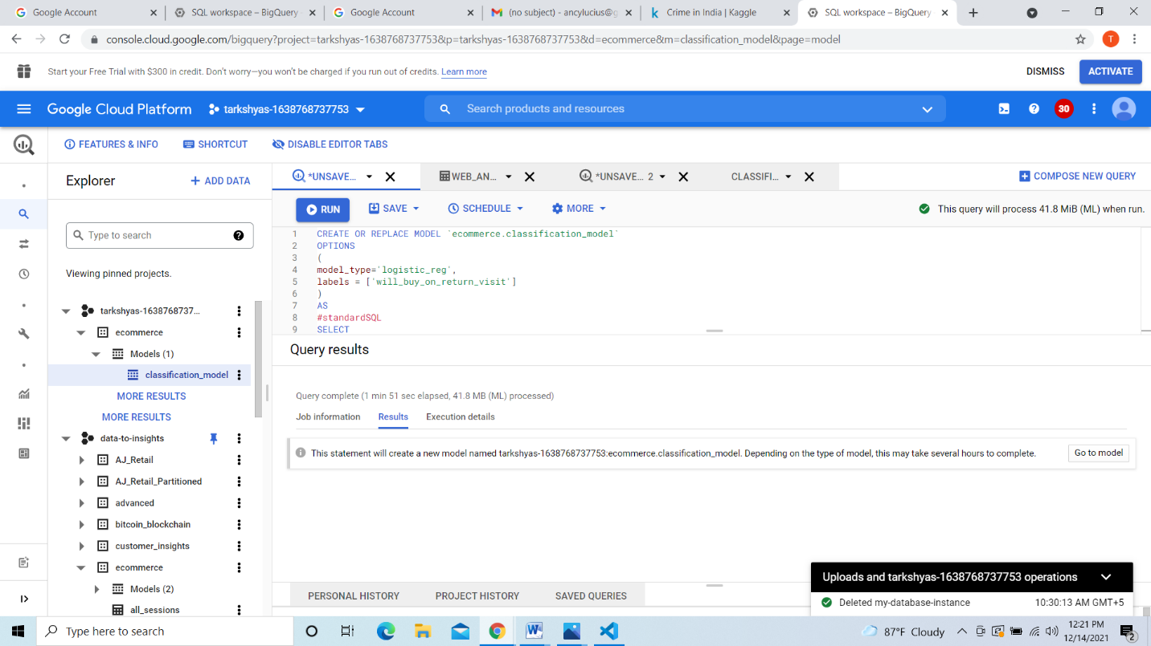

**10 create a vm and host a sample website**

Tagged and pusher docker of website in container registry

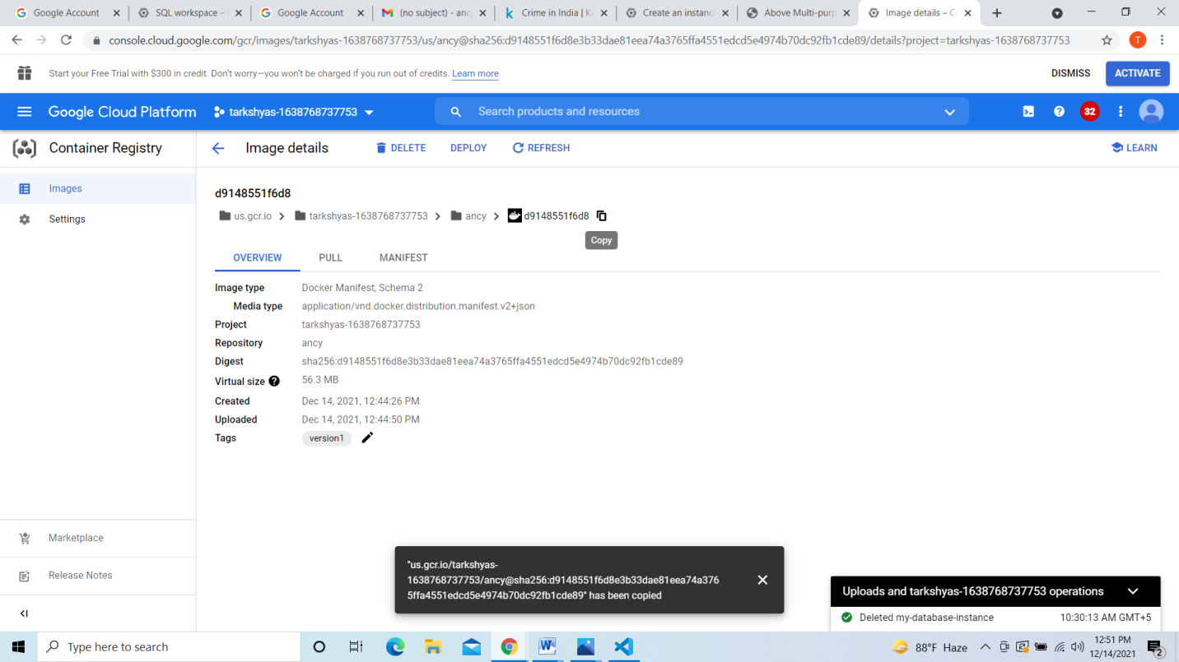

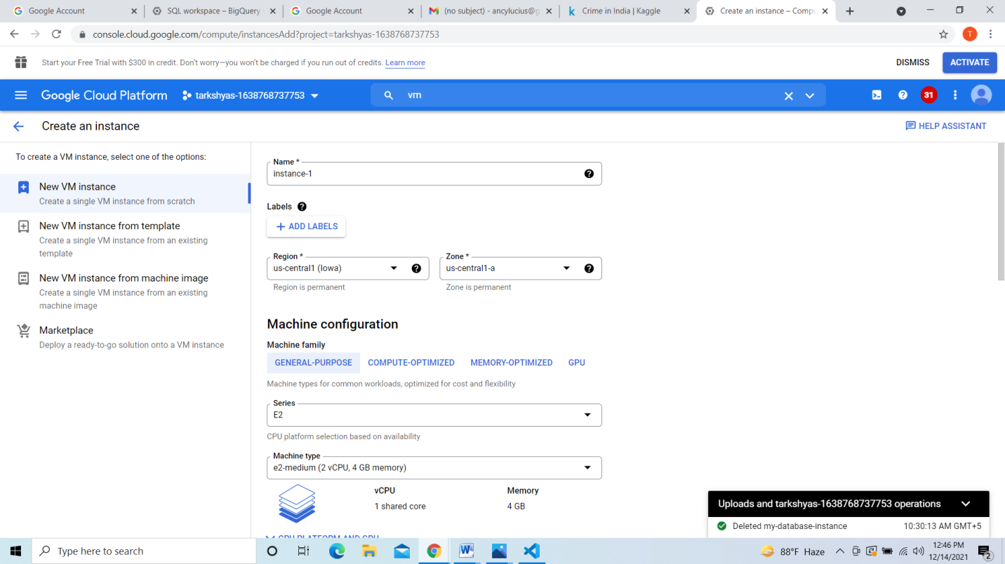

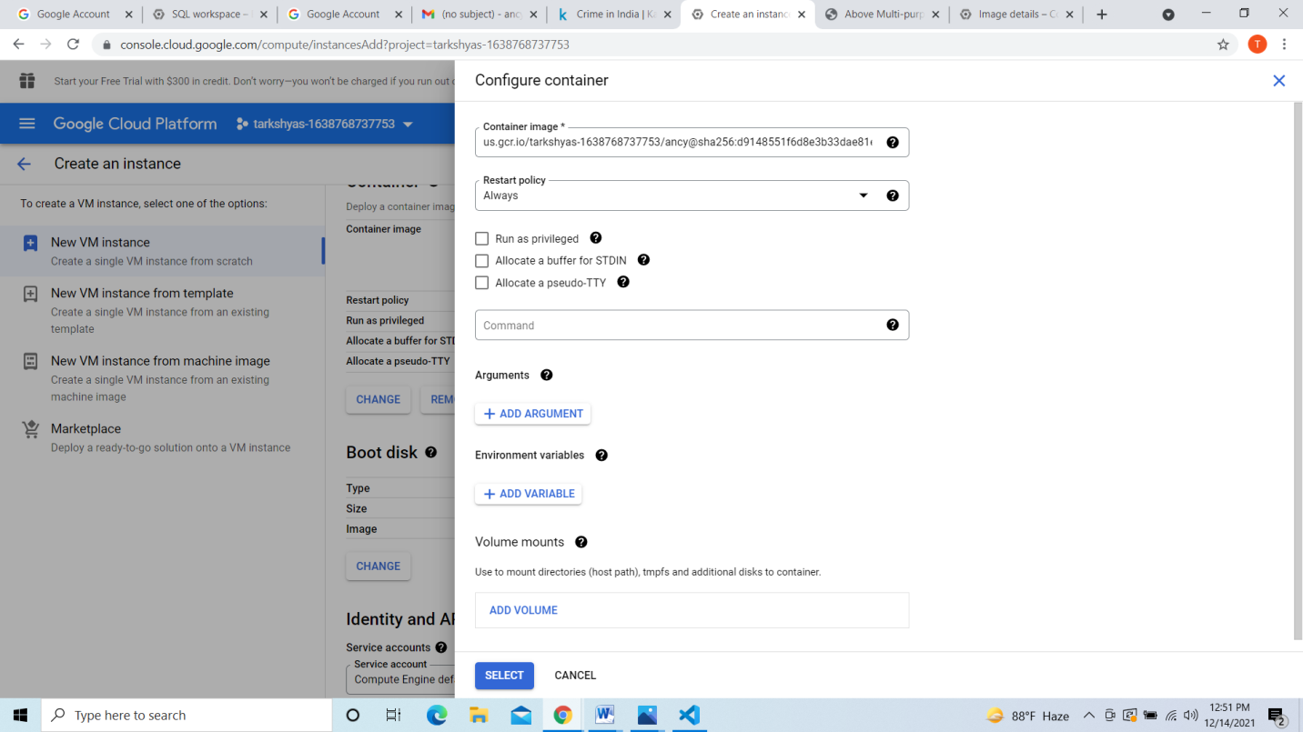

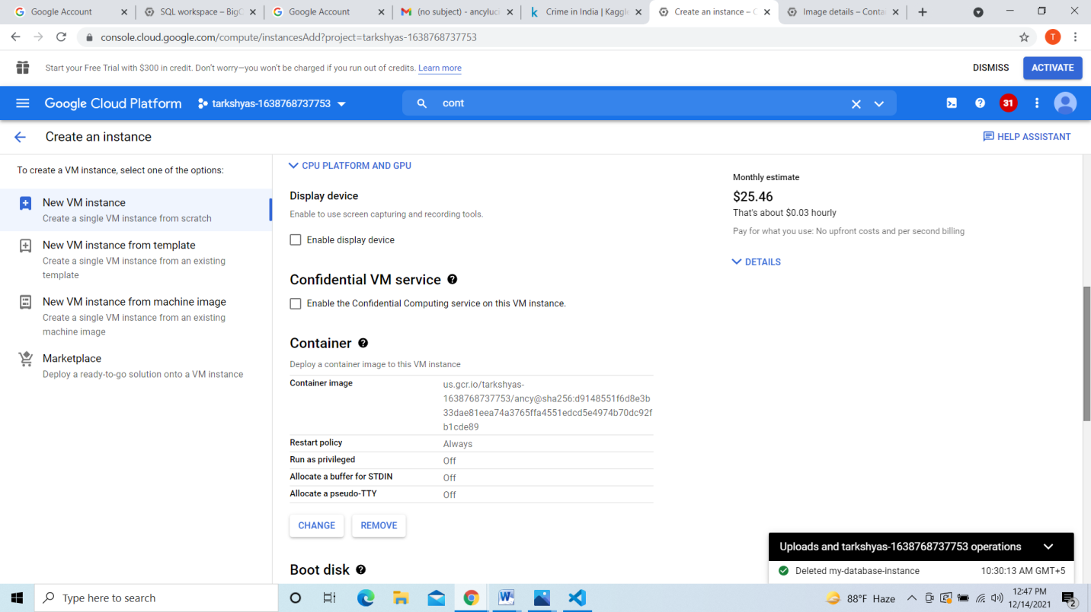

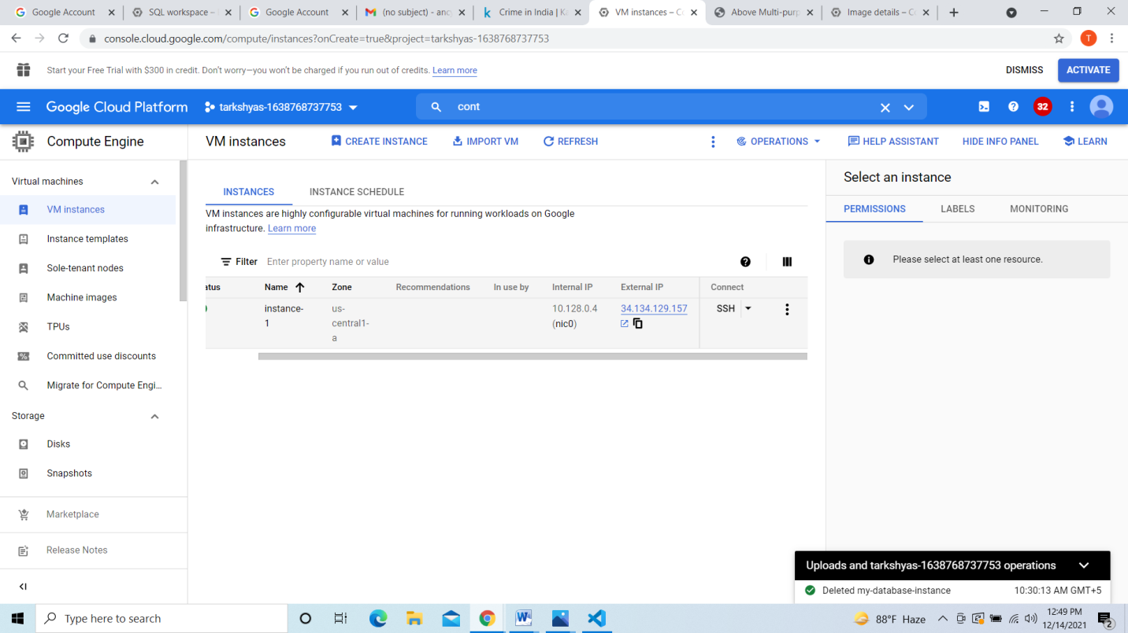



**11.Host a website given below in app engine standard environment:**

[**https://github.com/GoogleCloudPlatform/python-docs-samples/tree/main/appengine/standard/cloudsql**](https://github.com/GoogleCloudPlatform/python-docs-samples/tree/main/appengine/standard/cloudsql)

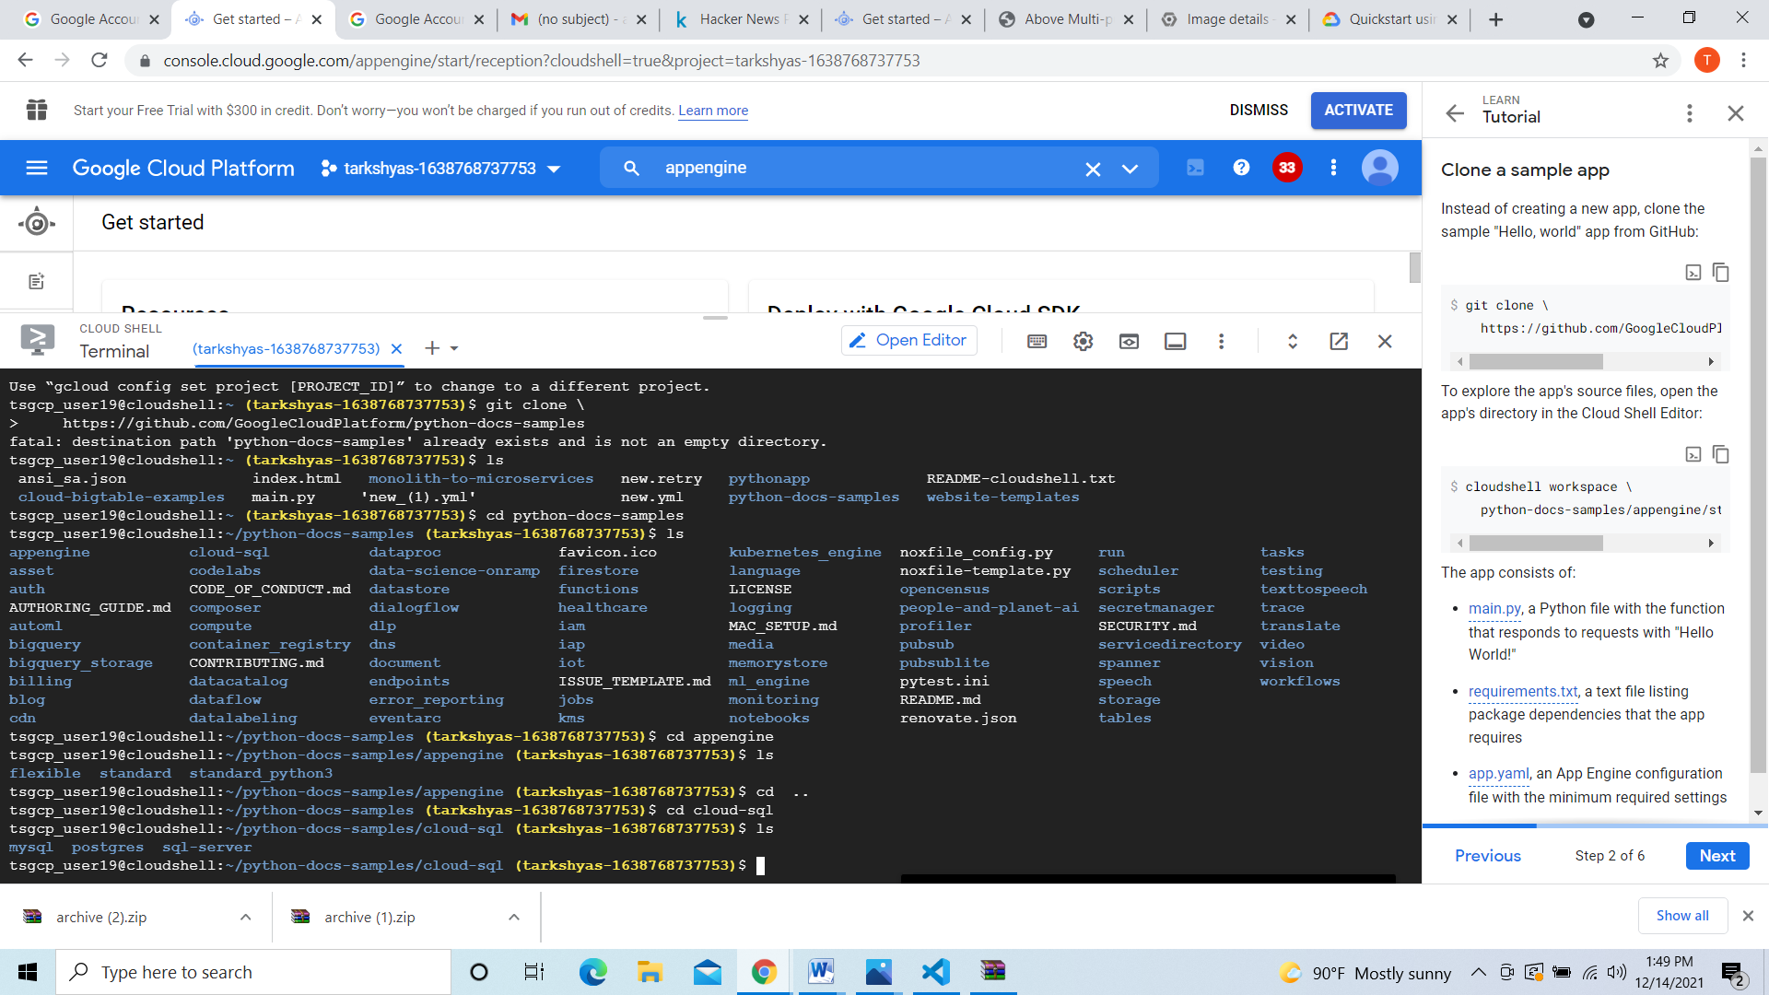

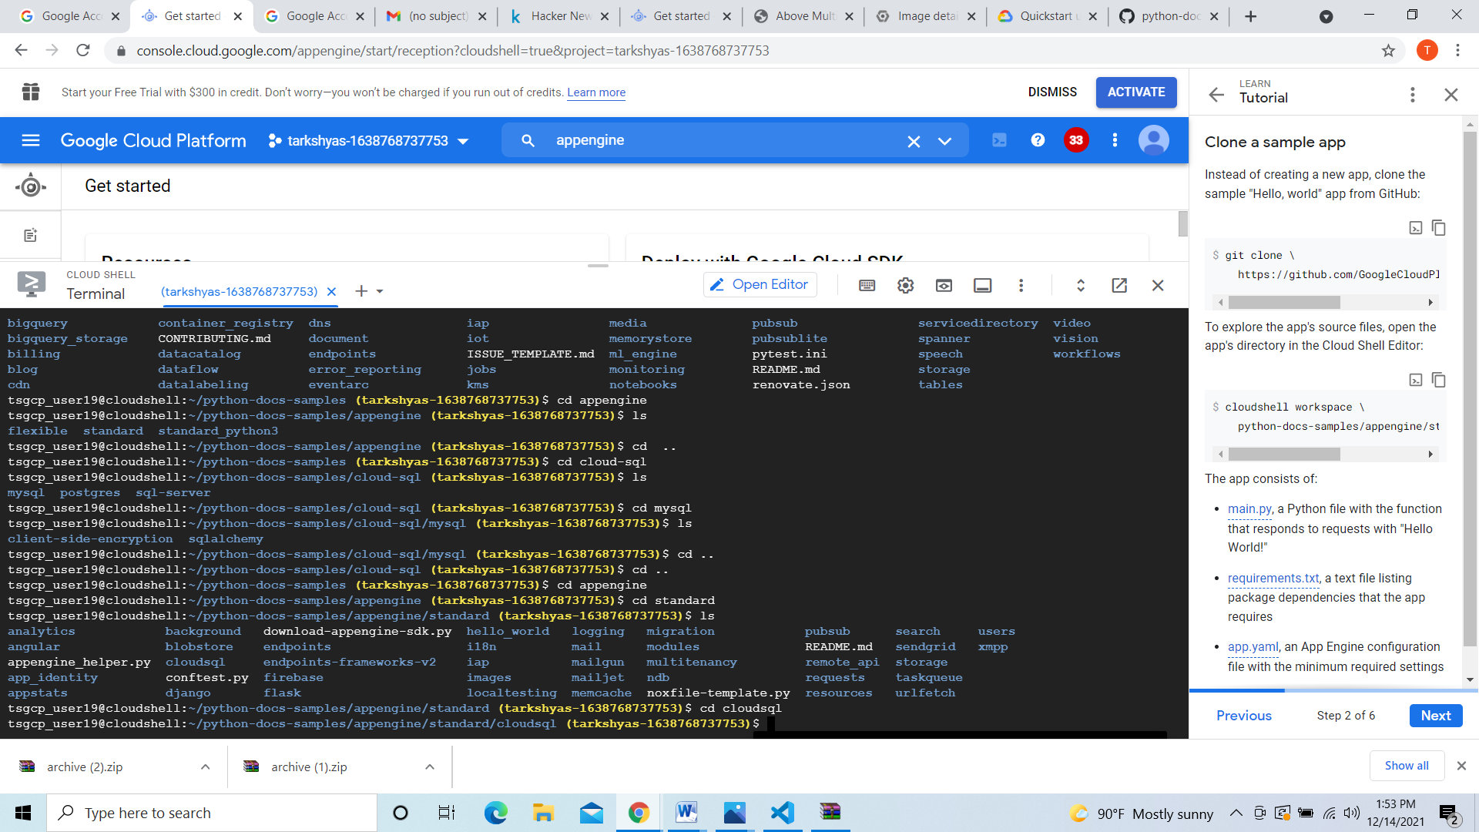

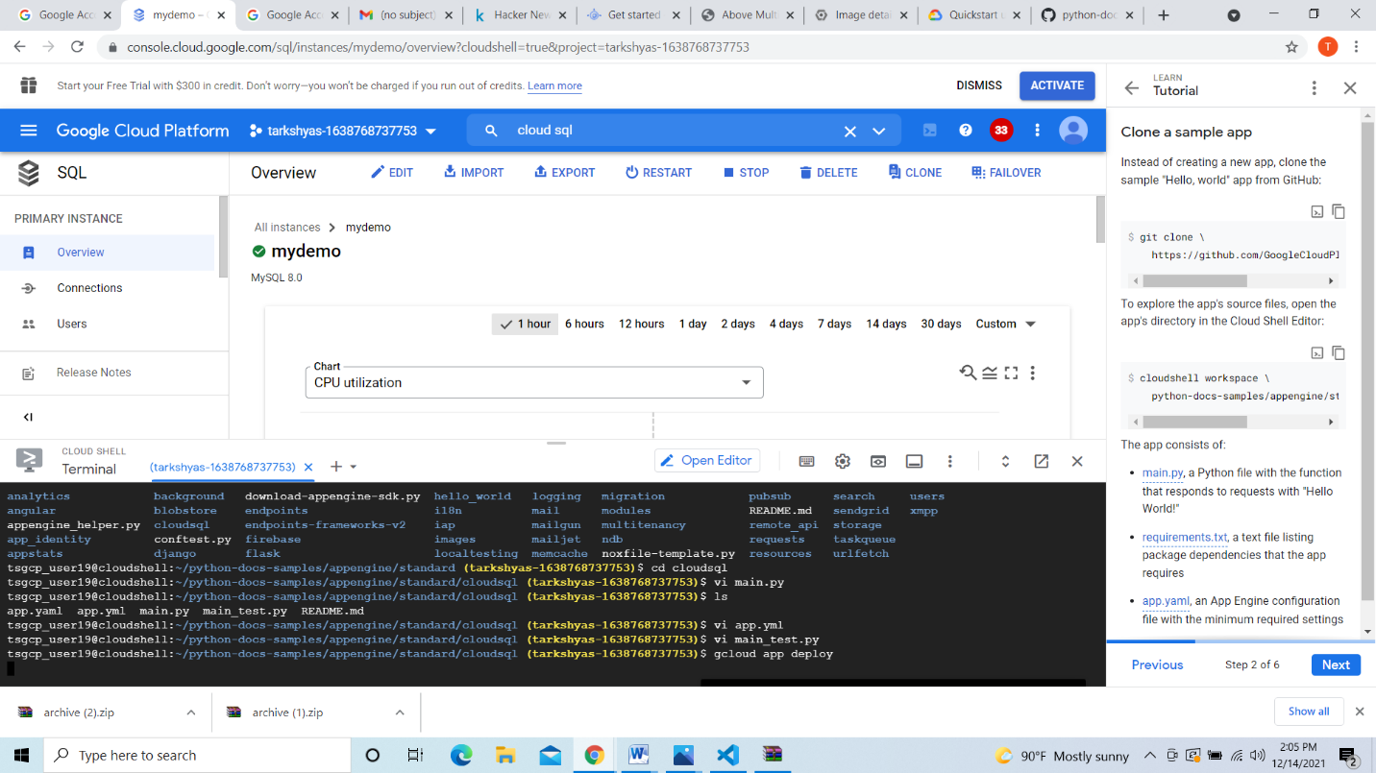

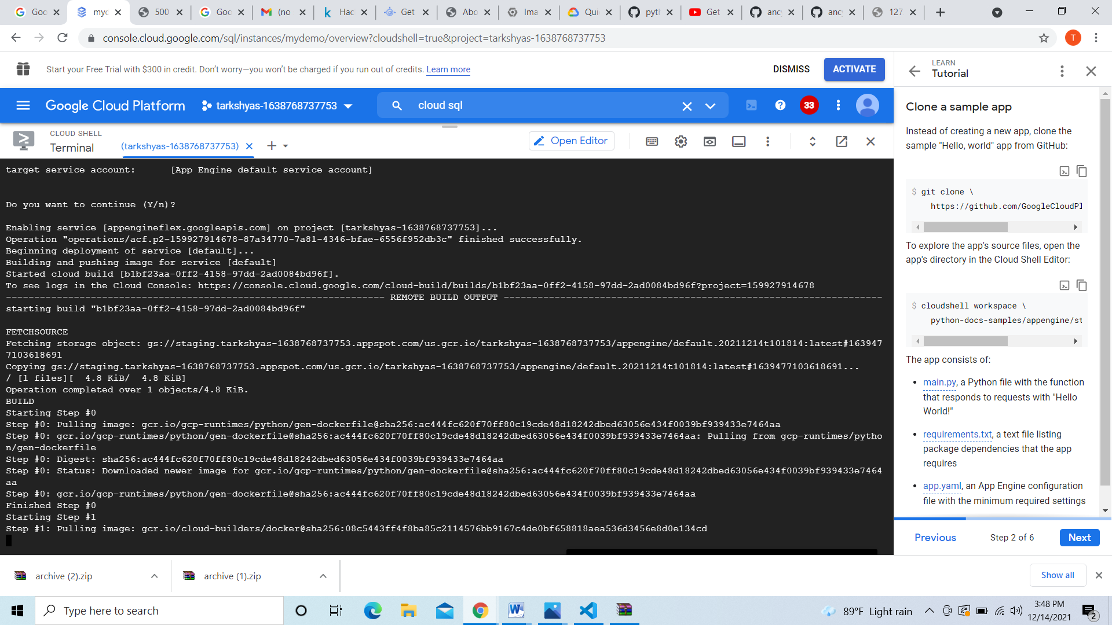

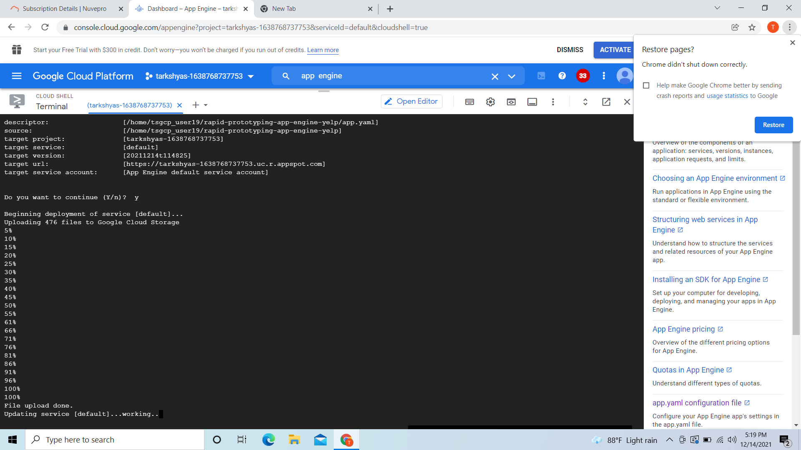

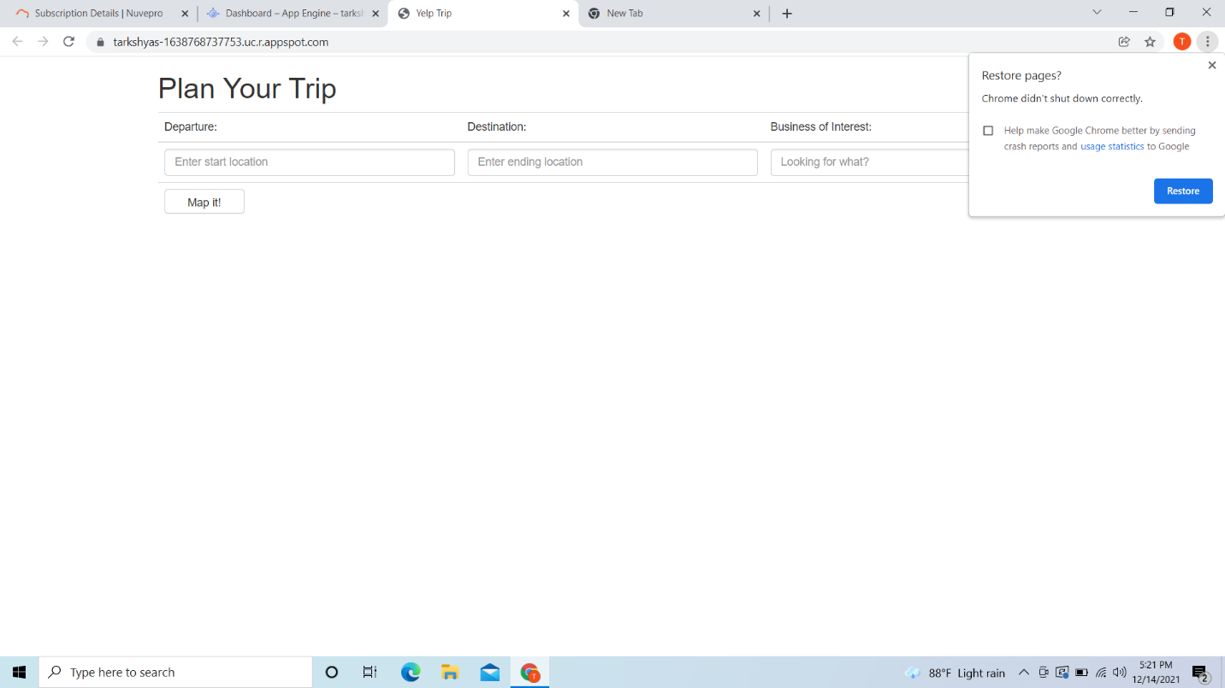

**12.host a website given below using app engineflexible environment:**

[**https://github.com/GoogleCloudPlatform/python-docs.samples/tree/main/appengine/flexible/django_cloudsql**](https://github.com/GoogleCloudPlatform/python-docs.samples/tree/main/appengine/flexible/django_cloudsql)





